DAVENPORT ’ S
NEBRASKA WILLS AND
ESTATE PLANNING
LEGAL FORMS

written by attorneys
Alex Russell and Robert Maxwell



Copyright © 2023 -- ALEX RUSSELL

CREATIVE COMMONS LICENSE. This work is also licensed under a Creative Commons Attribution-NonCommercial-NoDerivatives 4.0 International License.

GOVERNMENT WORKS. No claim is made to copyright or ownership of government materials.

SOME STANDARD FORMS. No copyright or ownership is claimed of “standard” for ms or leading for ms for the state which are provided in this book, but fair use and privilege to use is claimed. Makers of such for ms (often a state agency or hospital) have agreed by word, act, and implication the for ms may be used and copied if no profit is sought and no substantial changes made to them.
Such makers if not a lawyer or law firm are barred from profit or advantage in practicing law by making for ms then limiting use. For ms and other related materials are used for educational purposes only. Authors strongly believe in a religious duty to help people and do charity.

PUBLICATION DATA
(infor mal, library may use different data)

Names: Russell, Alex, 1972- author ; Maxwell, Robert, 1960- author

Title: Davenport’s Nebraska Wills And Estate Planning Legal For ms

Other Titles: Davenport’s Wills

Description: Davenport Publishing 2023

Suggested Identifiers: 9798865680062, LCCN 2021909030, 9798748423373

Subjects: LCSH: Wills--United States;
Wills--United States--For ms;
Estate Planning--United States;
Legal For ms

Classification: LFF KF755 .C55 2022 (or as library chooses)
DDC 346.73 Rus--dc23 (or as library chooses)

9 8 7 6 5 4 3 2 1 0 0 0 0 0 2 3

PERMISSION TO COPY AND USE BOOKS FOR FREE

To help people and groups publisher and authors of the book allow mostly free use by giving
all a "Creative Commons Attribution-NonCommercial-NoDerivatives 4.0 International License”.
Most users face no limit on copying, using, holding in library to loan out, or giving out copies.

Basically, as the image below says, any copying or use is OK if it still shows it is by the authors, is non-commercial ( nc ) with no price charged, and has no derivatives ( nd ) so no big changes.


(This work licensed under a Creative Commons Attribution-NonCommercial-NoDerivatives 4.0 International License.)

TO GET COPIES OF BOOKS USE WWW.DAVENPORTPUBLISHING.COM OR AMAZON.COM.

EMAIL QUESTIONS TO DAVENPORTPRESS@GMAIL.COM

WARNING. .

THIS PUBLICATION IS NOT A SUBSTITUTE FOR LEGAL ADVICE. Publisher and authors say and warn this publication is not giving any legal, accounting, or other professional services or advice, which if wanted can be obtained by consulting in person an attorney or some other professional. No attorney-client relationship or any relationship creating a duty or obligation is agreed to or created by the purchase or use of this publication or for ms.
.

BOOKS AND FORMS FOR OTHER STATES ARE AVAILABLE,
SEE WWW.DAVENPORTPUBLISHING.COM FOR INFORMATION
CHAPTER TABLE OF CONTENTS PAGE NUMBER

1 – Book Basics And List Of For ms 1 1

2 – Terms, Property Law, And Helpful Infor mation For m 4

3 – Will Basics 8

4 – Wills Gifts Including Residue Clause 10

5 – Debt, Marriage, And Child Issues 15

6 – Basic Ideas About Health Care For ms 18

WILL RELATED FORMS .

7 – For m 1: Will (Standard) 19

8 – For m 2: Will (Guardian) 23

9 – For m 3: Self-Proving Affidavit 27

10 – For m 4: Tangible Personal Property List 29

11 – For m 5: Handwritten Will 31

HEALTH CARE FORMS .

12 – For m 6: Health Care Power Of Attorney 33

13 – For m 7: Living Will Declaration 36

14 – For m 8: Do Not Resuscitate Order 38

GIVING POWER FORMS .

15 – For m 9: Statutory For m Power Of Attorney 40

16 – For m 10: Temporary Delegation Of Parental Powers 48

17 – For m 11: Authorizing Agent Affidavit For Remains 50
. .

Appendix : Sample Filled Out For ms 52

CHAPTER 1
BOOK BASICS AND LIST OF FORMS

ESTATE PLANNING CONTROLS THINGS IF LATER ABSENT, SICK, OR DEAD
This book is about Nebraska people doing legal documents to control their health care, property, money, children, funeral, and more if later they’re absent, sick, or dead. People have a right to control these matters so judges, doctors, and others mostly ask : “Based on what a person wrote what did they likely want done?”

ESTATE PLANNING MOSTLY IS DOING SIMPLE THINGS IN 3 AREAS
Estate Planning is mostly doing simple things in 3 areas : Will Related, Health Care, and Giving Power. This book has 11 ready to use Nebraska legal for ms. Many people use just a few of these legal for ms.

WILL RELATED FORMS - -

For m 1. Will (Standard) – a Will (also called a Last Will And Testament) lets a person control things after their death like who later gets money and property, who is Executor, and if easier legal options can be used.

For m 2. Will (Guardian) – Will with part added to name a Guardian to care for a minor child under 18 if needed (like if both parents later aren't available) and also if needed manage a child's money and property.

For m 3. Self-Proving Affidavit – for m often done with a Will to later help show it was signed correctly.

For m 4. Tangible Personal Property List – lets person easily later add some small gifts to their Will.

For m 5. Handwritten Will – Will which if all handwritten by person doing it can skip need for 2 witnesses.

- HEALTH CARE FORMS - -

For m 6. Health Care Power Of Attorney – lets a person name someone to control their health care if the person is later incapacitated and also lets person give some instructions about their health care.

For m 7. Living Will Declaration – lets a person do serious act of saying stop most health care if later doctors think the person is incapacitated and more health care almost certainly won’t help them.

For m 8. Do Not Resuscitate Order – does serious act of saying to paramedics, doctors, and others immediately from now on do not try resuscitation like C.P.R., and the for m is short to be read fast anywhere.

- GIVING POWER FORMS - -

For m 9. Statutory For m Power Of Attorney – lets power over money, property, and more be shared with a trusted person so they have power to do things, like use accounts, pay bills, get records, or sell items.

For m 10. Temporary Delegation Of Parental Powers – lets a parent share power with someone over
a minor child under age 18 to use if needed including health care and school issues.

For m 11. Authorizing Agent Affidavit For Remains – lets a person give instructions and if wanted name someone else other than closest family to control issues with their funeral, burial, and similar matters.

NEBRASKA LAW ON ESTATE PLANNING COVERS MOST PEOPLE HERE
This book is only for Nebraska since Estate Planning law and legal documents do vary between states.
Usually a state’s Estate Planning law applies if a person’s primary residence is here (often called “domicile”).
Many judges say “residence” occurs if a person lives in a place and for a moment has no clear plans to leave.
Later plans to move don’t matter till people actually move. Note, people can stay under their previous state’s
Estate Planning laws after they move from it if people have some plans to leave any new state eventually.
For example, people who move to a new state for months or more for travel, school, work projects, or the military often can keep legal ties to their old state. Immigrants here of any kind can do Estate Planning.
For health care people often do legal documents to match the state a hospital or other health facility is in.

BOOK IS SHORT, HAS FORMS TO QUICKLY SEE, AND USES EMPHASIS
This book is short and may read rough but can be read fast. Long books often lead to misunderstanding
of the basics and skimming. This book has legal for ms people can quickly see. For emphasis paragraph titles, underlining, and boxes are used. This book capitalizes some legal words like Will, Testator, and Agent but this is optional. To save space some small words are skipped and end quote marks put before punctuation.

THIS BOOK COVERS MAJOR LEGAL IDEAS AND SHOULD SUIT MOST PEOPLE
This book covers the big U.S. legal ideas on Estate Planning and major ways Nebraska law is a bit different.
This book can’t cover all issues but should suit almost all people without some strange situations or wishes.
Strange situations or wishes that needs more research or a lawyer include: a) strange gift wishes for property and money, b) wealth over $5 million, c) big medical concerns like extreme age, d) property or money going to
a person with a disability or special needs, and e) wish to move or hide assets to qualify for government help.

LEGAL FORMS CAN HELP MANY AND THIS BOOK HAS “STANDARD FORMS”
Legal for ms are good at most things involved in Estate Planning and can make binding legal documents.
Instead of legal for ms a lawyer can be used for Estate Planning but it can be costly, take months of work, and they can make mistakes. In life people often pick a cheap option. Importantly often a hospital, state agency, charity, or state legislature has made a for m most people use and call the “standard for m”, and doctors, judges, and other people may not like to follow anything else. This book does provide most standard for ms.

ESTATE PLANNING OFTEN IS NOT VITAL AND WORTH SPENDING MUCH ON
Despite what many people think Estate Planning often does not greatly change the costs, taxes, delays, and work involved in these areas, so it often is not vital and worth spending much money and energy on.
Benefits seem very low for young people even if they’re parents since only about 4% of people die by age 50,
and only about 0.13% of children under 18 had both parents die to need big legal help. See Social Security Tables: Felicitie Bell ; Parent Mortality Census SIPP Paper #288. Instead of costly Estate Planning many people buy life insurance, like some people pay yearly for $100,000 term life with no exam (“simplified issue”).

ANYONE CAN FILL IN MOST OF FORM, AND LATER TRY TO KEEP ORIGINAL
When filling out a legal for m except for signatures other parts can be filled in by someone not doing the
for m with good handwriting or typing. After a for m is done usually people try to keep the original and hand
out copies. Some people have everyone sign multiple copies to have multiple copies with ink signatures.
LEGAL DOCUMENTS MAY NEED TO BE “WITNESSED” OR “NOTARIZED”

To be legally valid and enforceable some legal documents need to be “witnessed”, which is someone watching the person doing the for m sign and then the witness signs too. Some legal documents need to
be “notarized”, which is a person who is a “notary” see signing and then use ink stamp and they sign too. Notaries (also called a “notary public”) are at some banks, brokers, insurance agents, courts, law offices, libraries, and mailing-copying centers. Using a phonebook to find a notary willing to help is recommended.
The words “subscribe” or “execute” means a person signed it, and “acknowledgment” means a person said
a signature was theirs. If a person signs a legal document in a foreign language it is still usually binding.

SOME LESS COMMON OR LESS USEFUL FORMS ARE NOT IN THIS BOOK
This book skips some possible but less common or less useful documents.

● A “Codicil” can modify a Will but it is easier and legally safer to just rewrite the whole Will.

● Some people do a “Pet Trust” to help a pet, but it’s easier to just give money in Will to person given a pet.

● Some people do a “Revocable Living Trust” so a Trust entity with a Trustee holds property or money during their life, usually done to after death have faster transfer of things and avoid small delays, costs, or work of others (by “avoiding probate”). But this is rarely done as it may require moving most of a person’s things to
a Trust causing maybe years of hassle, mostly to avoid later small work for people happy to be getting things.

● “Childrens Trust” papers can be done (like as part of a Will) so at a death a Trust gets money or property
for a minor child to manage until 18, but this is uncommon due to possible cost and hassle, since it rarely
matters (as this book explains), and since most Wills already arrange other legal help for young children.

PROBABLY DO NEW FORMS IF DIVORCE, MARRY, HAVE CHILD, OR MOVE
Divorcing, marrying, having a new child, or moving to a new state can have big legal effects, and if
any of these events occur it is recommended people do a new Will and other Estate Planning papers soon.
To help most states say a Will from another state is still valid if people move but this is not always certain.

NO FEDERAL OR NEBRASKA TAX IS USUALLY OWED DUE TO A DEATH

Usually no or little tax is owed as a result of a death, including estate, inheritance, or death taxes.
The Federal Estate And Gift Tax is the only tax that usually applies at the Federal level, and it only starts when a tax credit is used up covering $13.61 million a person in 2024 or later.
Nebraska has a state inheritance tax that might applies to a person getting things from a Nebraska resident who died or getting property physically located in Nebraska after the owner somewhere died.
The inheritance tax owed is based on a recipient’s relationship to the owner (the “Class”) and the amount.
Those recipients in the “Tax Free Class” never owe tax, and this includes a spouse of the person who died, a charity, and any child or grandchild or sibling of the decedent if such a person isn’t over age 21.
Recipients in “Class 1” each get the first $100,000 of money or property tax free, and then owe just 1% on the rest, and this includes a parent, grandparent, and child or grandchild or sibling (if over age 21).
Recipients in “Other Classes” get the first $25,000-$40,000 tax free and then owe a tax from 11% to 15%.
In-laws and a decedent’s spouse’s relatives are mostly treated like direct relatives. Most people getting things usually are close family so will owe little tax. Life insurance payouts are mostly tax free. Nebraska may one year lower this tax. For all these reasons usually people don’t need to worry about these taxes.

CHAPTER 2
TERMS, PROPERTY LAW, AND HELPFUL INFORMATION FORM

Some legal terms and ideas are basic to Estate Planning.

 “Estate Planning” is about people doing legal documents to control things if later absent, sick, or dead. After a document is done people are mostly free to sell or transfer property, instruct doctors, or change for ms.

 A “person doing a legal document” and “doing a for m” means the for m is for and affects that person.

 A “Will” or “will” (this book uses upper case “W”) is a legal document done to control issues after death.

The phrase “Last Will And Testament” is used since a “Testament” long ago was a small document done along with a Will to do some things. If no Will is done a person is described as being “in testate”.

 A person who died is called the “decedent” or “deceased”. A person getting a Will gift is called “recipient”, “beneficiary”, or “heir” if related (they “inherit”). “Survive” or “surviving” is to be alive after someone died.
The term “descendants” or “issue” usually means a person’s children and grandchildren.

 A person named to handle and do things after someone’s death is usually called an “Executor”, but if a judge has to pick someone they are called an “Administrator”. The term “Personal Representative” covers both these terms and is now the common term used in Nebraska for a person doing things after a death.

 A person doing a Will is called “Testator” or “Will maker”. Before about 2000 a woman Testator was
called a “Testatrix” and woman Executor called an “Executrix” but this is no longer often said or written.

 “Probate” is a legal process to do things after someone’s death like transfer property, handle creditors, and authorize a Guardian. Due to nice changes in law probate is now often infor mal, faster, and less costly.
 “Property” is either: 1) “real property” which is land and buildings (“real estate”), 2) “personal property” which is things not real property, like cash, accounts, stocks, tools, clothes, cars, jewelry, and art, or
3) “fixtures” which are things tied to real property (like fences, posts, lighting, and wired-in appliances).

 In Nebraska a person under 18 is usually called a “minor” and often a parent or guardian helps them.
A minor or other person not reasonably able to make wise decisions lacks “capacity” and is “incapacitated”.

 A document giving power to someone is often called a “Power of Attorney” where the “Principal” gives power to someone called the “Agent” or “Attorney-in-Fact” (but they needn’t be a real attorney or lawyer).

 State law is the “Nebraska Statutes” or “Nebraska Revised Statutes” (revised means updated). A law is often called a “statute” or “section” shown by a “§” or “s” mark. State law is broken into about 100 Chapters. A Nebraska law can be cited in a few ways, like Nebraska Statutes § 30-2327 or Neb. Rev. Stat. § 30-2327. A legal for m written in state law for people to find and use if wanted is usually called a "statutory for m".
“ESTATE” MEANS PROPERTY OF DECEDENT AND ENTITY HOLDING THINGS

First, the “estate” or “probate estate” means all property and money of a dead person that at death or soon after didn’t somehow legally automatically go to new owners. Second, estate is also the word for the temporary entity run by an Executor to do things after a death (it’s like a small corporation). A dead person’s money and things may be renamed or put in an account with an estate name, like “Estate of Max Luke Hud”.

PERSON CAN ONLY GIFT IN WILL WHAT THEY OWN AT DEATH
A person can only gift by Will things they own at death so people should research what they do own.
Basically by law a person usually owns all they earn as wages and salary, owns their share of income
and profit tied to property they own, and owns or partly owns any things their money buys or improves.
And for property with “title” documents (real estate or vehicles) or where there is a “listed owner” (like accounts) the named persons are usually the legal owners unless evidence shows special circumstances.
Note, a person during life can sell property, make gifts, or transfer things even if they are named in a Will, so people should consider if they already sold or gave away property they also name in a Will gift.

THINGS OWNED IN SPECIAL WAYS MAY LIMIT GIFTING IN WILL
A person should consider if they own real estate or other property in special ownership ways which may limit gifting by Will. Laws vary in different states but some common special ways of ownership are:

● “joint tenant with right of survivorship” or similar legal options, so then property transfers automatically to
the other named owners regardless of a Will, which in some states is often how spouses hold their home;

● papers say a “life estate” exists, so then if life of someone ends the other people in papers get item; and

● “Trust property” occurs if paperwork made a Trust entity and then property was transferred into it or this
is set to occur, so then the Trust papers control where things put in the Trust go after someone’s death.

Plain “joint ownership” with many people owning a thing can occur if people do joint papers, all agree to it, buy with joint funds, or if a gift was to many. Wills can gift joint property, like “I give my half of boat to Ed Hu”.

NON-PROBATE TRANSFERS THAT HAPPEN AUTOMATICALLY IGNORE A WILL

It is vital to know some money or property of a decedent may automatically transfers on death or soon after to new owners if certain arrangements were made. This is called “non-probate property”. Such things transfer as arranged even if a Will names the same items. Examples are: a) a “designated beneficiary” for m was done that names people to get an account or investment, b) transfer-on-death accounts were used, and
c) real property is held by 2 people as “joint tenants with survivorship” or similar so at a death the surviving person gets things. Usually property in a Trust will ignore a Will and transfers as the Trust papers say to.
Life insurance usually goes to the beneficiary named in insurance for m s. Trying to do non-probate transfers for all things is called “avoiding probate”, but few people try this since it can cause years of hassle, benefits are small, and often a tiny thing is missed. When doing a Will people should consider non-probate transfers that will occur automatically on death and consider what property and money will then be left to follow a Will.

SOME PEOPLE DO A HELPFUL INFORMATION FORM AND ATTACH PAPERS
People can do a information form and attach papers so family after death know things. See next pages.
ESTATE PLANNING HELPFUL INFORMATION .
For more space attach copies of for m or blank pages. Keep pages by Will or other place for Executor or family.

1. Personal Infor mation (Name, Birthdate, Social Security number, special family details, other):

2. Real estate, vehicles, and other major tangible property (especially if people may not find them):

3. Non-tangible assets like stocks, accounts, investments, loans owed you, and business interests:

4. Possible income or insurance like pensions, retirement, disability, insurance, or contracts:

5. Debts owed by you like credit card, loan, student loan, mortgage, vehicle loan, and accounts payable:

6. Names and infor mation of professionals used (attorneys, accountants, brokers, doctors, others):

7. Computer passwords and helpful files, document places, and safes or safe-deposit boxes codes/keys:

8. Other helpful things, wishes for funeral, special requests, and any last messages to family and friends:

CHAPTER 3
WILL BASICS

WILL LETS “TESTATOR” CONTROL THINGS AFTER DEATH
A Will is done by a person to control some things after their death. A person doing a Will is called the “Testator” or “Will maker”. A Testator when signing must be at least 18 years old, of sound mind (rational with sufficient memory), and not be under duress (unfair pressure or threat).

. A WILL USUALLY MUST BE SIGNED WITH 2 WITNESSES .

WILL MUST SHOW IT’S A WILL AND BE SIGNED WITH 2 WITNESSES
A document to be a Nebraska Will usually must shows it is a Will by its words, and the person doing it must sign it in front of 2 persons acting as witnesses who then sign too. A Will spoken on a video or audio recording with no writing usually has no legal effect in Nebraska. But a Will that is all handwritten by the person doing it may be able to skip using 2 witnesses, and this Handwritten Will is covered later in this book.

WITNESSES SHOULD BE PEOPLE AT LEAST AGE 18
A person to witness a Will must be at least age 18. It is slightly better if witnesses are not very old or live far away like out of state. It is also preferable that witnesses are not getting Will gifts (see next paragraph). Though it is allowed it is also preferable a witness not be named as Executor, Guardian, or to a similar job in the Will. Often used as witnesses are friends, family members, workers in an office, and strangers.

WILL GIFTS TO A WITNESS LIKELY WON’T BE CARRIED OUT
A Will is still valid even if 1 or more witnesses to the Will are named to get things in the Will. But Will gifts to a person who acted as a witness usually are invalid and won’t later be carried out unless there is at least 1 witness who signed who is not getting gifts in the Will (a “disinterested” witness). A small exception says
a witness can get up to the amount they’d get by “intestate law” which normally applies if there is no Will.
To avoid this issue often 2 people are chosen to be witnesses who are not named in any Will gifts.

TESTATOR AND 2 WITNESSES SIGN THE WILL WHEN TOGETHER IN 1 ROOM
The person doing the Will should sign it with 2 witnesses who then also sign. Everyone should be in 1 room and see others sign. Witnesses and Testator showing each other an ID is not required but is common. A Testator or witness should use their full legal name unless they dislike it and rarely use it. The Testator need not initial the Will pages. Witnesses only read the 1 paragraph they sign. In this book’s Will for ms are spaces for the witnesses to print their names and addresses by their signatures. Disabled people who can’t sign by hand should see a lawyer. Legally a Testator need not say anything, however often a Testator says a thing like, “My name is ___ and this is the Will I want and do voluntarily and want you 2 people to witness”. Some Testators also chat a few minutes more with witnesses to help show they are of sound mind.

KEEP SIGNED WILL IN SAFE PLACE IT CAN BE FOUND AFTER A DEATH
People should keep a Will so it can be found within days of a death, like in a desk, drawer, safe, or less often a safe deposit box. It can be given to a person to hold. It may help to tell others how to find or get a Will.
A living person can deposit their Will at court for safekeeping (and withdraw it if wanted) but this is rarely done.
CANCELING OLD WILLS IS USUALLY NOT A PROBLEM
So a new Will is followed old Wills should be canceled (“revoked”) but this is easy and rarely a problem.
A new Will usually quickly says old Wills are revoked to cancel them, and all this book’s Will for ms say this.
A few people revoke an old Will by writing “void” or “cancelled” or “X” on it, preferably with a witness to this.
Usually crossing out just part of a Will has no effect, and revoking a Will doesn’t bring back an earlier Will.

MOST WILLS SAY TO SKIP COSTLY BOND FOR EXECUTOR AND OTHERS
Most Wills helpfully say no “bond” or “surety” is required for any Executor, Guardian, or similar people.
This is insurance bought from a company to insure against misconduct. But the person writing a Will usually doesn’t want this since the persons named are trusted and buying insurance uses up estate assets.

MOST WILLS SAY FAMILY MAY LATER DO “INFORMAL PROBATE”
Most Wills say after a death family and friends may later do “infor mal probate” which can avoid costs and delays. Infor mal probate often is done with just 1 short court hearing and usually is done in under 1 year.

MOST WILLS HAVE A “MISCELLANEOUS” PART WITH HELPFUL LANGUAGE
Most Wills have a “Miscellaneous” page with paragraphs of legal language to avoid some legal problems. This can help if later legal problems occur. A person doing a Will need not understand these paragraphs.

. A WILL NAMES AN EXECUTOR TO DO THINGS AFTER DEATH .

WILL NAMES SOMEONE AS “EXECUTOR” TO DO THINGS AFTER A DEATH
Usually a Will names someone as “Executor” to act after a death like handle debts, find and collect and give new owners property and money, and do probate. The law gives Executors many helpful legal powers.
If a Will fails to name an Executor a judge can pick someone, but family may argue about who to suggest. The term “Personal Representative” and not the term Executor is now often used in Nebraska for the person doing things after a death, but these terms mostly mean the same thing. Will gifts can go to an Executor.

EXECUTOR CAN BE PAID AND ESTATE PAYS FOR EXECUTOR’S EXPENSES
In Nebraska normally an Executor can ask to be paid for the time they spend working on estate things, and sometimes paid to them is 1-4% of the value of the estate. Some Testators don’t want this and add a line to a Will saying don’t pay Executor at all. But many Executors just skip asking for pay to not owe income tax on it and leave more resources to carry out Will gifts. Expenses an Executor has like for insurance, probate, repairs, mortgage payments, utilities, and similar things are paid for using estate money or property.
Any lawyer an Executor hires usually is paid hourly or as the Executor and lawyer agree.

EXECUTOR IS PERSON AT LEAST 18 AND SECOND PERSON RARELY NEEDED
A person to be Executor must be 18 or older and usually not have a bad criminal record like a felony.
A person to be Executor need not reside in Nebraska but being local can make their later work much easier. Naming 2 people to both be Executor is allowed but rare due to the risk of arguments and delays, and since any 1 person named should be trusted. People can name a 2nd person to be Executor if the 1st person
is not later available but most skip this since this rarely occurs and if needed a judge can pick someone.
To add a 2nd person a person could add: “or if they’re reasonably unable to serve I name _______ to serve”.

CHAPTER 4
WILL GIFTS INCLUDING RESIDUE CLAUSE

MAIN USE OF A WILL IS TO SAY GIFTS TO HAPPEN AFTER DEATH
Most people use a Will mainly to say what happens to their property and money after their death, usually by writing down various Will gifts to occur when they die. Verbal and even writings about this are not usually valid if not in a proper Will. A Will can control property acquired after it was signed. The very end of this Chapter covers “intestate law” which says where a person’s things go at death if no valid Will handles this.

GIFTING IN A WILL USING SIMPLE WORDS OFTEN IS BEST
Making gifts in a Will using simple words is often best, using words like “I give to” and “I gift to”. This is legally fine and avoids confusing legal words like “bequest”, “devise”, and “legacy” which few people know.

A PERSON IS MOSTLY FREE TO GIFT THEIR THINGS AS WANTED
A person is mostly free to give at death their money and property as they want. But creditors a decedent owed money, a spouse, and minor children under age 18 may have rights which this book later explains.

IN WILL CAN DO “SPECIFIC GIFTS” TO GIFT PARTICULAR PROPERTY
Most Wills have “specific gifts” to gift particular things. Specific gifts can be any property, like “I give boat to Ed Blom” and “I give UBank account #84553873 to Sue Wu”. If a gift is not clear the law assumes all of a kind of thing is given, like “I give jewelry to Ann Po” means all jewelry. But gifting specific property can have surprises like value of items can change, or a Will gift may later fail to occur if property is not owned at death.

IN WILL CAN DO “GENERAL GIFTS” LIKE OF MONEY
Wills can do “general gifts” where what is gifted is not particular property but can be flexibly chosen, like “I give 1 of my 3 cars to Ed Po” which lets an Executor pick which car. The usual general gift is money, like “I give $5 to Ed Hill”. Money gifts are easy to write, let equal gifts be made, and are safer since specific items might not be owned at death. To carry out money gifts an Executor uses some accounts or sells property.

“RESIDUE CLAUSE” IS CATCH-ALL THAT HELPFULLY GIFTS ANYTHING LEFT
Most Wills by their end have a Residue Clause to gift property or money not gifted in a Will or used in other ways, often called a “catch-all” or “left-over” clause. The Residue Clause is covered later in this Chapter.

PROPERTY OR MONEY IN A “JOINT GIFT” GOES TO MULTIPLE PEOPLE
The same property or money in a “joint gift” can go to many people to each get a part. For example,
“I give boat and all hats to Ann Wu and Sue Han” means each person owns 50% of every item. People later can split things by agreement or an Executor can decide how to divide items. If a person in a joint gift has died their part usually is left to transfer under the Residue Clause.

GIFTS IN WILL CAN GO TO A GROUP OR CLASS OF PEOPLE
To save work a Will gift can go to a group or class of people especially family if who is meant is later
easy to determine. People can say about how much in total is gifted to be clearer. Examples are: “I give $10 to each person on my 2018 dart team” and “I give $10 to each of my grandkids so this is about $80 in total.”
GIFT BENEFICIARIES CAN GET PERCENTAGE RATHER THAN EQUAL SHARE

If a Will gift goes to multiple people the law assumes equal shares, but if wanted percentages can be used to make unequal gifts, like “I give boat 90% to John Smith and 10% to Mary Baker”.

AFTER A DEATH FAMILIES OFTEN LET PEOPLE TAKE ITEMS UNOFFICIALLY
Many families unofficially let people take items in ways a dead person mentioned, put on a note or stickers, or would want, and this is usually fine. If anyone objects a judge may have the Will followed but later people can voluntarily retransfer items. This book also covers how Tangible Personal Property Lists can gift things.

CAN LEAVE SOME WILL GIFT LINES BLANK OR WRITE THINGS LIKE “SKIPPED”
A person writing a Will can choose to not use some gifts lines in a Will legal for m, like by just leaving
them blank, writing things like “SKIPPED” or “NONE” in them, or using a computer to delete some gift lines.
Judges and others usually do not care about neatness or empty spaces in Wills.

LATER DIVORCE OR MURDER CANCELS WILL GIFTS
Nebraska law says a person divorcing or murdering a Testator usually cancels all Will gifts to the person.

CONDITIONS ON WILL GIFTS ARE RARE DUE TO POSSIBLE PROBLEMS
Conditions on a gift, like “I give Ed Poe $90 if he enters college”, can cause problems so is rarely done.

. OPTIONS EXIST TO HANDLE RARE CASE PERSON IN A WILL GIFT DIES .

PERSON MUST SURVIVE OR GIFT TO THEM DOES NOT OCCUR
Though rarely an issue, many Wills like this book’s Will forms say a person named in a Will gift must survive (live past) the Testator or the gift will not later occur unless gift language specifically says different. If survival isn’t required like this then what occurs can be unclear (for many reasons like certain state laws).
Most people if they see a person in a gift has died just re-do a Will or trust a Residue Clause to handle it.

SOME PEOPLE ADD “ALTERNATE BENEFICIARY” MAYBE FOR SPECIAL ITEMS
Some people to handle if a person named in a Will gift dies maybe put for special items an alternate beneficiary, like for example: “I give oak table to Ed Wu but if they don’t survive me to Ben Fox”.

IF PERSON IN WILL GIFT DIES IT CAN GO TO “LINEAL DESCENDANTS”
A Will gift can say it goes to a person but if they don’t survive the Testator then say the gift goes to the person’s “lineal descendants”. Descendants are a person’s children and grandchildren. Also, the term
“per stirpes” is often used to say to give to each family branch equally. An example shows how this works:

A Will may say: “All clothes to Sue Wu but if they don’t survive to their lineal descendants per stirpes”,
and this means if Sue Wu has died and her son Ken Wu is living and her other son Ben Wu has died
but left 2 children then, legally, by law Ken Wu himself gets 50% and Ben Wu’s 2 children each get 25%.

HELPFUL LAWS OFTEN REQUIRE PERSON SURVIVE 120 HOURS TO GET GIFT
Laws in most states say a person dying within 120 hours of someone is seen as having died earlier, so often a Will gift to them is ignored. This avoids legal problems like need to know exact time of death and, also, having an item go through many probate legal cases over years.

. RESIDUE CLAUSE GIFTING ALL LEFT IS MAIN WAY USED TO GIFT THINGS .

THE “RESIDUE CLAUSE” IS CATCH-ALL THAT HELPS GIFT ANYTHING LEFT
Most Wills by their end have a Residue Clause to gift any property or money not gifted earlier in a Will or
used in other ways. Things transferred this way is called the “Residue”. Many people gift most their money
and property this way by intentionally not mentioning in a Will most things so the Residue Clause handles it.
This avoids need to describe things and has less legal risk. After applying a Residue Clause if anything is
somehow left then by law a decedent’s closest heirs-at-law get things (this is their closest family).

USUAL RESIDUE CLAUSE HAS 2 PARTS
A short 2 part Residue Clause is usual and is used in this book’s Will for ms, and it has:
1) 1st space to name 1 or more persons to get things if they survive Testator (many name a spouse or
closest family here), and if several people are named but only some survive then survivors split things, and
2) 2nd space to name persons to get things if all in the 1st space don’t survive (many people name next
close family or friends in this space), and if a person in 2nd space has died their descendants get their share.

EXAMPLE OF 2 PART RESIDUE CLAUSE:

“RESIDUE CLAUSE: I give money and property not gifted earlier:
A) to . my husband John Paul Doe . if they survive me, then
B) to . Sam Doe my son, Beth Wu my daughter, and Greta Fisher my friend .and if any of
those just named do not survive me their part goes to their lineal descendants, per stirpes.”

In this example if John Paul Doe has survived then he gets all things, but if John Paul Doe hasn’t survived
and also Sam Doe hasn’t survived and he left 2 daughters then those 2 daughters split the 1/3 share of
Sam Doe so get 1/6 each and other 2 persons in second part Beth Wu and Greta Fisher get 1/3 each.

SOME PEOPLE USE PERCENTAGES, REPEAT NAMES, OR SKIP A PART
Some people use percentages in a Residue Clause to get the exact split wanted. This can be used to gift
a lot (like to a person’s children) or can be used to gift a small bit (like to a grandchild or more distant people).
Some people put the same names in both clause spaces or skip part of it to do certain things. For example, a
person with no spouse may skip the 1st part and in 2nd part name their children (including any who died who
had kids of their own) so all branches of a person’s descendants get a share.

SOME PEOPLE CHANGE A RESIDUE CLAUSE TO HAVE 1 PART
Some people change a Residue Clause to have just 1 part since this can gift more equally and be easier
to understand. See example in Appendix. For example a Residue Clause can be made to say:

“The rest, residue, and remainder of my estate, and anything else, I give to: _____ who survive me and
if any people just named do not survive me their part goes to their lineal descendants per stirpes.”

. MUST SUFFICIENTLY DESCRIBE NAMES AND PROPERTY IN A WILL .

PUTTING NAMES OF PEOPLE OR GROUPS IN A WILL IS FAIRLY EASY
Putting names in Wills is fairly easy. A judge or Executor assume a person in a Will meant people they know, so common names are OK unless 2 friends or family have the same name. Details can help if names won’t be recognized or to be friendly, like “I give $5 to my nurse Sue Ax” and “I give $5 to loyal pal Ed Lee”. If people used a nickname “also known as” or “a / k / a” may help, like “I give $5 to Dan Smith a / k / a Old Fishy”. Gifts can go to a charity, government, or group, like “I give $80 to The Salvation Army, “I give $10 to Douglas County Library, NE”, and “I give $5 to Lob Church, Rex, Texas”. People often phone to get a charity’s name.

PUTTING DESCRIPTIONS OF ITEMS IN WILL GIFTS IS FAIRLY EASY
Describing items in gifts is easy since people rarely own similar items. Often fine are gifts like: “I give ax to Ed Wu” and “I give big table to Ann Fox”. It’s OK to gift by category or list, like: “I give tools to Sam Lee” and “I give cow, van, and harp to Sue Hill ”. Financial assets can use plain words, like “bank accounts” or “stocks”, but details can help, like: “US Bank account ending #1511”. Gifting using a location is riskier as judges will ignore Will gifts if it seems items were placed to affect gifting and no “independently significant” life reason.
So, “I give Ed Po items in safe and desk” judges might not follow, but “I give Ed Po hats in attic” likely is OK.

DESCRIBING REAL PROPERTY IS HARD SO MANY USE RESIDUE OR TITLE
The easier and safer way to gift real property (real estate) at death is: 1) do nothing specific so it’s handled by a Will Residue Clause, or 2) have a broker or lawyer add names to a deed or similar to get real property.

Gifting real property other ways is harder though possible. Helpfully a Will gift of real property described by location legally does gift all land, buildings, and fixtures located there with no need to describe what’s there.

It is possible to gift real property at a particular address with very plain words, like a house, fixtures, and land can be fully given by something like: “I give 21 Salem Road, Lincoln, Nebraska to Mary Ellen Brown”.

Or people can do a blanket gift giving all of a kind of property, like, “I give all real property and fixtures in Sarpy County, Nebraska to Ann Sue Hill” or “I give all real property and fixtures in any place to Paul Ian Rex”.

Giving real property in a Will using a “legal description” is how many lawyers do it, but this can be hard to do.
If using a legal description people must copy without mistakes the full legal description of maybe many lines into a Will with no abbreviation at all. A legal description might be found on a deed or on mortgage papers. Legal descriptions may refer to a “lot” or “blocks” in a subdivision which is recorded in land records of a county, or it may refer to a path around the land borders with various angles, distances, and iron stakes.

INTESTATE LAW CONTROLS THINGS NOT COVERED BY A WILL .

“INTESTATE LAW” CONTROLS THINGS NOT HANDLED BY A WILL OR SIMILAR

State “intestate law” which is at Neb. Stat. § 30-2302 says where property and money goes if people die with no valid Will, if anything is left after a Will is followed, and if no other transfers apply. Many people like what intestate law says and intentionally skip doing a Will. If it applies intestate law mostly gives a dead person’s things to closest surviving (living) family. Note, if a person’s child has died then any living children of them (the grandchildren) often get things in their place which is called “representation”.

In the rare cases Nebraska intestate law applies, like if a person left no valid Will, it basically says in order:

1. If a person left a surviving spouse but no surviving children and no parents, then the spouse gets all;

2. If a person left some surviving children and no spouse, then the person’s children get all;

3. If a person left a surviving spouse and children who are all from that spouse, then the spouse gets the first $100,000 plus 1/2 of the rest and all the person’s children split the rest;

4. If a person left a surviving spouse and children some of whom are not from that spouse, then the spouse gets 1/2 of things and all the person’s children split the rest;

5. If a person left a surviving spouse and also some surviving parents of the person, then the spouse gets the first $100,000 and 1/2 of the rest and the person’s parents get the rest;

6. If a person left no surviving spouse, children, or parents, then things go to any descendants of the parents (so the person’s brothers and sisters, and nieces and nephews);

7. If a person didn’t leave any of the above surviving persons then other close relatives like the person’s grandparents and relatives of the grandparents get things; and

8. If a person leaves no surviving close family then things go to the state of Nebraska which is very rare.

SIMPLE WILL WITH MOST GIFTING DONE BY RESIDUE CLAUSE IS OFTEN BEST
Writing a simple Will without many gifts, much left blank, and mostly using a Residue Clause is often best.

If there is a spouse often a person does small gifts to friends and family, then uses the Residue Clause of the Will to gift all remaining to the spouse, and then names a few fallback persons in the Residue Clause.

If there is no spouse and no children often a person does a few small gifts, and then names some family or friends in the Residue Clause to get everything remaining.

A parent with young children if married to the other parent often does small gifts to friends and family, then in the Residue Clause gives mostly to a spouse, and then names children as fallbacks in the Residue Clause.

A parent with young children if not married or close to the other parent often does small gifts to friends
and family, and then uses the Residue Clause to gift all remaining to their children.
CHAPTER 5
DEBT, MARRIAGE, AND CHILD ISSUES

This Chapter covers complex debt, marriage, and young child issues. Some people can skip some parts.

. DEBT ISSUES . .

PAYING DECEDENT’S DEBTS MAY USE UP RESOURCES AND REDUCE GIFTS
If a decedent had a lot of debts any creditors may ask a judge to be paid from decedent’s money or property before Will gifts and certain transfers occur. How debts are paid is set by state law and a Will need not describe this. Funds to pay debts comes from decedent’s property and estate so may affect (in order) the Will Residue, Will general gifts, Will specific gifts, and non-probate transfers. Probate, health care, and funeral debts by law have priority to be paid first. Note, for various reasons often not all debts are ever paid.
People should consider how paying debts may use up money or property, leaving less to carry out Will gifts.
A spouse and family usually aren’t liable at all for decedent’s debts unless they guaranteed or co-signed.

“FAMILY RIGHTS” OR OTHER THINGS MAY BE USED TO GET FAMILY THINGS
Most states in laws have “family rights” a decedent’s surviving spouse or young children can choose to use, and this may let them get some of decedent’s things before most of decedent’s debts are paid back
and before Will and other transfers occur. Nebraska partly has these rights starting at Neb. Stat. § 30-2322.
First, a surviving spouse or children of a decedent can use the “Exempt Property” right to let them claim $12,500 of personal property of a decedent like furniture, clothes, tools, and cars (subtracting any car lien).
Second, a surviving spouse or dependent children can use the “Family Allowance” right to get money to live
on for 1 year or so during legal proceedings, and often family get a sum equal to decedent’s post-tax income.
Third, a spouse or dependent children can use the ”Homestead” right to $20,000 from property or accounts of a decedent. But Nebraska state law does not give family a right to actually own decedent’s home if a Will, deed, or other thing doesn’t give them this (but certain legal steps may let family stay here a year or more).
Note, a surviving spouse’s “Elective Share” right to claim 1/2 of decedent’s estate is covered on the next page.

Obviously if a spouse or children use these rights this leaves less property and money of the decedent to
carry out Will gifts or other transfers so may interfere with these. So that family don’t bother to use family rights most people give mostly to any spouse or young children (like over 50% and any family house).

SECURED DEBTS LIKE MORTGAGE OR VEHICLE LIEN ARE NOT PAID OFF
Laws in most states say don’t pay off secured debts of a decedent like a house mortgage or vehicle lien
on property even if other debts are paid by Executor or in probate. This avoids using up estate funds on
paying these usually big debts and leaves more estate resources to carry out Will gifts and other transfers.
All this book’s Will for ms say don’t usually pay off secured debts. But if a Testator really wants they can
1) put in a Will an order to pay (like, “Executor pay off the house mortgage”), or 2) gift enough money to pay
off a debt to the person getting a property. Most banks after a death let new owners keep paying monthly
any secured debt like a mortgage or lien on property they got from the decedent.

MARRIAGE ISSUES .

MOST STATES USE “SEPARATE PROPERTY LAW” FOR SPOUSES
Nebraska and most states use the “Separate Property Law” system saying that a married person mostly
owns their money and property separately and not jointly with a spouse. Therefore a spouse is mostly free
to sell during life or gift by Will any money and property they own separately and not involve their spouse.
But joint ownership by 2 spouses and not separate ownership can arise in many ways, like by agreement, paying half a purchase price, a gift was to both spouses, or if joint paperwork is done. Also many married
people do a deed or other papers so a house on 1 spouse’s death automatically goes to the other spouse.

“COMMUNITY PROPERTY” LAW APPLIES IN OTHER STATES FOR SPOUSES

There are 9 states mostly in West and South U.S.A. that use “Community Property” law for spouses there (Arizona, California, Louisiana, Idaho, Nevada, New Mexico, Texas, Washington, and Wisconsin).
This law basically says property or money is owned 50/50 by spouses as Community Property if it comes from physical or mental effort while living there while married (like labor or wages, managing a business, or active trading of a collection or stocks) or if it was bought or improved with other Community Property. Most people in Nebraska avoid these issues unless they recently moved from any of these states.

SPOUSE CAN CLAIM “ELECTIVE SHARE” INSTEAD OF THEM FOLLOWING WILL
A spouse if unhappy with what a Will and other transfers may give them has a right to instead choose (elect) an “Elective Share” of a dead spouse’s property and money rather than take what a Will says they get.
Most states do this for a spouse for fairness, so a spouse has resources to live on, and so early divorce isn’t the only way to be financially secure. The Elective Share is usually set at 1/2 of the deceased spouse’s estate, property, and money (with some subtractions for things the decedent gave to their spouse during life).
The law will count some things the decedent gave away recently and has other parts that try to not let people easily get around this right. Clearly a spouse using the Elective Share to get half or so of a decedent’s things may use up much of what decedent had and interfere with other transfers. To avoid a spouse wanting to use the Elective Share most people give over 1/2 their things to any spouse (including any family house).

. CHILD ISSUES .

WILL CAN NAME “GUARDIAN OF THE PERSON” TO CARE FOR YOUNG CHILD
If a parent dies with a child under 18 any other natural or adopted parent (but not a step-parent) almost always automatically gets control of the child’s care (including health care, school, and home issues).
This won’t occur only if they’ll be unavailable a long time or are proven unfit in court which is very rare.
But just in case it is later needed (like if later both parents die) a Will often names a healthy and willing
relative or friend to be if needed “Guardian of the Person” to care for a child and have these powers.

WILL CAN NAME “GUARDIAN OF THE ESTATE” TO HANDLE CHILD’S PROPERTY
Since a child until age 18 can’t legally manage money or property a Will often names a person to act as “Guardian of the Estate” to manage the child’s property and money (some call this person the “Conservator”). They decide each year how to use this property and money for a child’s costs (like school, living, and health care) till usually age 18 when all left goes to a child. Judges often hold a yearly hearing to review spending. Anyone paying things for a child can ask to be paid back from a child’s money and property. And as a nice option most Wills at the end say an Executor may instead let a "Custodian" they pick manage a young child’s property or money just like a Guardian of the Estate does. This is allowed by the new “Unifor m Transfers
To Minors Act” law which lets a Custodian do these things with less work, costs, and delays than usual.

MOST WILLS NAME 1 PERSON TO CARE FOR CHILD AND THEIR PROPERTY
This book’s Will for ms and most people name the same person to be Guardian of the Person caring for a child and also be Guardian of the Estate caring for a child’s money and property. People can change a Will to name different people for the 2 positions. But naming different people is rarely worth it since parents dying is rare, rarely do children get much, a person smart enough to handle a child usually can handle money, and naming different people can lead to arguments and lawsuits over spending. Nebraska law tends to call any person helping a child just as a “Guardian” so one may need to specify which areas each Guardian controls.

PERSON TO BE A GUARDIAN MUST BE AT LEAST 18 AND NOT A BAD CRIMINAL
A person to be a Guardian must be 18 or older and not have a bad criminal record like a felony, but they need not reside in Nebraska but being local can make work easier. Choice for Guardian by the last living parent usually is followed. If no Will names a person to be a Guardian or they’re unavailable a judge can pick someone, but family may argue about who to suggest to a judge. Naming 2 people for 1 position to act at the same time is rare since 2 persons may argue and any 1 person named should be smart enough to act alone. People can name 2 people to a position if they are a married couple, but this can cause problems if they disagree or divorce so is rare. Some Wills add a 2nd person to serve if the 1st person is unavailable, like: “or if they are later reasonably unable to serve I name __ to serve”). But most people skip naming a fallback person since it’s rarely needed, if a problem is seen a Will can be redone, and a judge always can pick someone.

NAMING GUARDIANS RARELY MATTERS DESPITE PARENT’S WORRYING
A young child having parents die is rare so parents shouldn’t worry that much about this. A very large U.S. study of 311,900 people found 72,240 were under 18 and of these 2014 had lost 1 parent (2.78%) and just 97 both parents (just 0.13%), so losing parents is very rare. Parent Mortality Census SIPP Paper #288.
CHAPTER 6
BASIC IDEAS ABOUT HEALTH CARE FORMS

SOME BASIC IDEAS HELP PEOPLE UNDERSTAND HEALTH CARE FORMS

Some ideas help people understand health care for ms.

 By law people control their health care unless “incapacitated” by insufficient ability to a) communicate verbally or by notes, b) be rational, or c) be conscious. Unless incapacitated people just tell doctors what health care they want. In actuality most people keep control of health care till death or till no big treatment options remain, but people may worry they may be incapacitated a long time so do some health care for ms.
For ms about control of health care if people are later incapacitated are often called “Advanced Directives”.

 If an adult 18 or older becomes incapacitated the adult’s closest family like spouse or adult child can make emergency decisions but they usually must then rush to a judge to get further power if no legal document gives them full power over health care.

 In for ms a person can be named to have control of health care if needed who is often called “Agent”.

 In for ms people can give written health care instructions doctors, family, Agent, and others must obey.

 Parents do have power over health care of their child under age 18.

 Some young married people give a spouse power over health care in case they are ever incapacitated.
Some young adults give this power to parents. Young people are less often ill so often skip doing things.

 Pain relief like pain drugs and comfort care is usually given even if for ms say to stop or limit other care.

 Most people only do a single long health care for m that has a spot to give someone power over health care and a spot for instructions (this is often called a “Health Care Power of Attorney” though names vary).

 For the rare times stopping health care (“pulling the plug”) likely matters due to extreme illness or old age:

-- most people do nothing special and trust family or Agent for health care to decide on stopping care based
on many factors like pain, cost, hassle, suffering and time of treatment, beliefs, and chances of recovery;

-- a few people do a serious document to say to stop most health care if later doctors decide a person is incapacitated, has an irrevocable terminal condition or likely won’t regain good consciousness, and more medical care won’t help (this document to stop care is often called a “Living Will” though names vary);

-- a few people do a serious document to starting immediately block certain health care (and this often is
called a “Do-Not-Resuscitate” if about resuscitation or called a “Physician’s Order” if about many treatments).
CHAPTER 7
FORM 1: WILL (STANDARD)

FORM 1 IS A STANDARD WILL THAT IS FLEXIBLE AND WITHOUT A GUARDIAN
For m 1 is a standard Will that is flexible and lets a person control many different things after their death.
This for m has no part about a Guardian so this for m is for a person with no minor child under age 18.
The person doing a Will is called the “Testator”. The word “Testament” is often used in a Will’s name
since many years ago this was a separate legal document often done alongside a Will.

FORM IS A WILL WITH SEVERAL PARTS
The for m starts with places for a person to put their name (a full legal name is best but not required) and current main residence (most put a county but some put a city). A Will is still valid if people later move.
The 1st paragraph, “Gifts”, has many spaces to make either specific gifts of particular property or general gifts like of money. People can delete, copy and paste to add more, or leave blank these gift lines.
The 2nd paragraph, “Separate Writings”, says to follow any separate writings done apart from the Will that gifts tangible personal property in manner allowed by state law.
The 3rd paragraph, “Residue”, has a Residue Clause to say property and money left after other Will
parts and other transfers is to be distributed in the way a person wrote in the blank parts of this paragraph.
The 4th paragraph, “Administration”, has a space to name a Personal Representative to handle legal and other matters after a person’s death (some states and people use the old term of Executor for this).
The 5th paragraph, “Miscellaneous”, has paragraphs of legal language to help avoid certain legal issues.
Last is 2 paragraphs for the person doing the Will and 2 witnesses to sign, date, and put their addresses.

USUAL RESIDUE CLAUSE HAS 2 PLACES TO NAME PERSONS TO GET THINGS
In a Will “Residue Clause” anything left over after other Will parts is transferred as the clause directs.
Many people use a Residue Clause to gift most their things. In this Will for m’s Residue Clause there is:

1) a 1st space to name 1 or more persons to get the Residue, and if any person named here has died
before the Will maker then any other persons named here in this 1st space take their share, and

2) a 2nd space to name people to get things if all people named in the 1st space have died , and if any
people named in the 2nd space have died their shares go to “lineal descendants” like their children..

People often put in the 1st space a spouse or closest family or friends, and in 2nd space next closest people.

TESTATOR AND 2 WITNESSES WHILE TOGETHER SIGN WILL
This Will after being filled out (except bits intentionally left blank) must be signed by the person doing
the Will (the “Testator”) in front of 2 persons acting as witnesses at least age 18 who then also sign the Will.
Testator and witnesses should be in 1 room and see all others sign. Usually people try to pick witnesses so no Will gift is going to them. Witnesses usually just read the 1 paragraph of the Will they are signing below. Though not required often a Testator says something like: “My name is ________ and this is my Will that I do voluntarily and want you 2 people to witness”. Once completed a Will usually should be kept so it can be found quickly within weeks of a Testator’s death.

LAST WILL AND TESTAMENT .

I, . . , of . . , Nebraska, do revoke all prior Wills and testamentary documents and do make, publish, and declare this as my Will. I am of sound mind and under no duress or undue influence and acting voluntarily.

1. GIFTS. I give these gifts in this Will, but to get a gift in this section the recipient must survive me except as otherwise stated below.

I give . . to . . .
I give . . to . . .
I give . . to . . .
I give . . to . . .
I give . . to . . .
I give . . to . . .
I give . . to . . .
I give . . to . . .
I give . . to . . .
I give . . to . . .

2. SEPARATE WRITINGS. I may do writings separate from this Will to gift tangible personal property as allowed by state law, and all such writings should be followed.
But any such writing not found within 90 days of my death is canceled and has no effect.
A gift in such a writing to a person who does not survive me is canceled and has no effect.
This Will does not revoke any such writings that now exist.

3. RESIDUE. I give the rest and residue and remainder of my estate, my money and property of any kind and nature, and anything I have an interest in so long as it was not transferred by other Will provisions (all of which is called the “residue”), as follows:

a) to . . who survive
me with persons just named who survive me taking the share of non-survivors, then

b) to . . and if any of those just named do not survive me their part goes to their lineal descendants per stirpes.

4. ADMINISTRATION. I nominate and appoint . . as Personal Representative including for me, my Will, and my estate.

5. MISCELLANEOUS. The following applies to this Will and generally.
In this document no unfilled part is a mistake and residue spaces may be left blank.
The facts support and Testator wants Nebraska law to apply to this Will and Testator.
Priority of Will gifts of the same type is based on the order they are written.
If a gift or section in this Will reasonably mentions survival in any way then such survival is an absolute condition and anti-lapse laws or similar have no effect.
The words “give” and “gift” also means a devise, bequest, grant, legacy, or similar.
A gift of property no longer owned by me at death shall lapse and be of no effect including no payment of money shall be done in its place.
Unless a Will gift specifies otherwise if a Will gift goes to multiple recipients if any
do not survive me their part to them lapses and instead goes to other surviving recipients.
I am intentionally not providing by Will or other ways for some family, such as some of my children and grandchildren, and this is intentional and not a mistake to be fixed.
No gift or transfer I made during my life to a person reduces or offsets a Will gift, unless during my life I expressly usually called it a loan or an advancement.
Unless another meaning is shown use of plural includes the singular and vice versa, “they” can mean 1 person, and masculine, feminine, and neuter words are interchangeable.
Unless a Will specifically says otherwise a) a secured debt including a mortgage or lien shall not be paid off including by a Personal Representative or in probate, b) a recipient of a Will gift of property takes it subject to debts, and c) no Will gift recipient who later loses property gifted to them to a debtor or who pays to avoid foreclosure or other loss may require the estate or anyone to pay recipient back, do exoneration, or do or pay anything.
I request and authorize any informal, summary, and quick probate or similar action.
Any Personal Representative may act independently with no supervision of any court, including independent administration, and with no inventory, appraisal, or other action.
I give any Personal Representative the a) fullest authority, discretion, and powers allowed by state law, b) power to lease, sell, mortgage, convey, or keep property including real property in a manner and time they deem helpful or proper, and c) authority to settle
or pay claims or debts as they in their sole discretion choose. Any Personal Representative is given all powers that may be given to or held by them by law.
Any Personal Representative has sole discretion how to divide a gift to several persons, how to carry out a general gift, and how to do a gift to multiple persons.
No lawyer hired by a Personal Representative should get a standard fee or percentage.
Any Conservator, Custodian, or similar person managing a minor’s property or money may use or invade the principal, sell property, and do any other action without court action.
If context permits the terms Personal Representative and Executor and Administrator are interchangeable, Guardian of the Estate and Conservator and Guardian of Property and Custodian are interchangeable, and residue and residuary are interchangeable.
The residue includes lapsed or failed gifts, insurance paid to the estate, any inheritances
owed, and property I have or had a power of appointment or testamentary disposition over.
Any Personal Representative, Executor, Administrator, Guardian of any type like for
a person or estate, Conservator, Custodian, and any other fiduciary under this Will or

otherwise shall qualify and serve without bond, surety, security, surety bond, or similar.
If evidence does not show it likely a person survived me by 120 hours (5 days) then for this Will and my estate they shall be deemed in all ways as having died before me.
If part of this Will is by law invalid or unenforceable other provisions remain in effect.
Any Personal Representative may at any time transfer money or property of a minor under age 18 to a Custodian to serve under the Nebraska Uniform Transfers to Minors Act or a similar law anywhere, and they may pick the Custodian including themselves.

TESTATOR

_;;;;;
IN WITNESS WHEREOF now do I, . . , the Testator,

sign my name to this instrument this . day of . , 20 . ,
and being first duly sworn if any authority is shown below, do hereby declare to the undersigned authority and declare for all other purposes that I sign and execute this instrument as my Will and that I sign it willingly, that I execute it as my free and voluntary act for the purposes therein expressed and that I am 18 years of age or older or am not at this time a minor, and am of sound mind and under no constraint or undue influence.

___________________________________
Testator Signature

WITNESSES

We, . . and . . , the Witnesses,
sign our names to this instrument, being first duly sworn and do hereby declare to the under signed authority if any authority is shown below, and declare for all other purposes that the Testator signs and executes this instrument as Testator’s Will and signs it willingly, and that Testator executes it as Testator’s free and voluntary act for the purposes therein expressed, and that each of us in the presence and hearing of the Testator hereby signs this Will as witness to the Testator's signing, and that to the best of our knowledge the Testator is 18 years of age or older or is not a minor, and is of sound mind and under no constraint or undue influence.

___________________________________
Witness Signature

. .
Name and Residence of Witness (printed)

___________________________________
Witness Signature

. .
Name and Residence of Witness (printed)

CHAPTER 8
FORM 2: LAST WILL AND TESTAMENT (GUARDIAN)

FORM 2 IS BASIC WILL WITH GUARDIAN CLAUSE FOR YOUNG CHILD

For m 2 is a Will with a Guardian part to be used by a person with a minor child under the age of 18.
The person doing a Will is called the “Testator”. The word “Testament” is often used in a Will’s name
since many years ago this was a separate legal document often done alongside a Will.

FORM IS A WILL WITH SEVERAL PARTS
The for m starts with places for a person to put their name (a full legal name is best but not required) and current main residence (most put a county but some put a city). A Will is still valid if people later move.
The 1st paragraph, “Gifts”, has many spaces to make either specific gifts of particular property or general gifts like of money. People can delete, copy and paste to add more, or leave blank these gift lines.
The 2nd paragraph, “Separate Writings”, says to follow any separate writings done apart from the Will that gifts tangible personal property in manner allowed by state law.
The 3rd paragraph, “Residue”, has a Residue Clause to say property and money left after other Will
parts and other transfers is to be distributed in the way a person wrote in the blank parts of this paragraph.
The 4th paragraph, “Administration”, has a space to name a Personal Representative to handle legal and other matters after a person’s death (some states and people use the old term of Executor for this).
The 5th paragraph, “Guardian”, names a person to if needed care for minor children as Guardian of the Person, and also if needed act as Guardian of the Estate to manage a child’s property and money.
The 6th paragraph, “Miscellaneous”, has paragraphs of legal language to help avoid certain legal issues.
Last is 2 paragraphs for the person doing the Will and 2 witnesses to sign, date, and put their addresses.

USUAL RESIDUE CLAUSE HAS 2 PLACES TO NAME PERSONS TO GET THINGS
In a Will “Residue Clause” anything left over after other Will parts is transferred as the clause directs.
Many people use a Residue Clause to gift most their things. In this Will for m’s Residue Clause there is:

1) a 1st space to name 1 or more persons to get the Residue, and if any person named here has died
before the Will maker then any other persons named here in this 1st space take their share, and

2) a 2nd space to name people to get things if all people named in the 1st space have died , and if any
people named in the 2nd space have died their shares go to “lineal descendants” like their children..

People often put in the 1st space a spouse or closest family or friends, and in 2nd space next closest people.

TESTATOR AND 2 WITNESSES WHILE TOGETHER SIGN WILL
This Will after being filled out (except bits intentionally left blank) must be signed by the person doing
the Will in front of 2 persons acting as witnesses at least age 18 who then also sign the Will. Testator and witnesses should be in 1 room and see all others sign. Most people pick witnesses so no Will gift is going to them. Though not required often a Testator says something like: “My name is ______ and this is my Will that I do voluntarily and want you 2 people to witness”. Witnesses usually just read the 1 paragraph of the Will they are signing below. Once completed a Will should be kept so it can be found within days after a death.
LAST WILL AND TESTAMENT .

I, . . , of . . , Nebraska, do revoke all prior Wills and testamentary documents and do make, publish, and declare this as my Will. I am of sound mind and under no duress or undue influence and acting voluntarily.

1. GIFTS. I give these gifts in this Will, but to get a gift in this section the recipient must survive me except as otherwise stated below.

I give . . to . . .
I give . . to . . .
I give . . to . . .
I give . . to . . .
I give . . to . . .
I give . . to . . .

2. SEPARATE WRITINGS. I may do writings separate from this Will to gift tangible personal property as allowed by state law, and all such writings should be followed.
But any such writing not found within 90 days of my death is canceled and has no effect.
A gift in such a writing to a person who does not survive me is canceled and has no effect.
This Will does not revoke any such writings that now exist.

3. RESIDUE. I give the rest and residue and remainder of my estate, my money and property of any kind and nature, and anything I have an interest in so long as it was not transferred by other Will provisions (all of which is called the “residue”), as follows:

a) to . . who survive
me with persons just named who survive me taking the share of non-survivors, then

b) to . . and if any of those just named do not survive me their part goes to their lineal descendants per stirpes.

4. ADMINISTRATION. I nominate and appoint . . as Personal Representative including for me, my Will, and my estate.

5. GUARDIAN. I hereby name . . to be if needed the Guardian of any minor child of mine to have care, authority, control, custody, and other control of them (including as Guardian of the Person). I also name this same person to be if needed Guardian for any minor child of mine or other minor person to have care, control, and power over their property, money, and estate (including as Guardian of the Estate). Any person acting as a Guardian I also name to act as Conservator for a minor and their estate, property, and money if this is helpful.

6. MISCELLANEOUS. The following applies to this Will and generally.
In this document no unfilled part is a mistake and residue spaces may be left blank.
The facts support and Testator wants Nebraska law to apply to this Will and Testator.
Priority of Will gifts of the same type is based on the order they are written.
If a gift or section in this Will reasonably mentions survival in any way then such survival is an absolute condition and anti-lapse laws or similar have no effect.
The words “give” and “gift” also means a devise, bequest, grant, legacy, or similar.
A gift of property no longer owned by me at death shall lapse and be of no effect including no payment of money shall be done in its place.
Unless a Will gift specifies otherwise if a Will gift goes to multiple recipients if any
do not survive me their part to them lapses and instead goes to other surviving recipients.
I am intentionally not providing by Will or other ways for some family, such as some of my children and grandchildren, and this is intentional and not a mistake to be fixed.
No gift or transfer I made during my life to a person reduces or offsets a Will gift, unless during my life I expressly usually called it a loan or an advancement.
Unless another meaning is shown use of plural includes the singular and vice versa, “they” can mean 1 person, and masculine, feminine, and neuter words are interchangeable.
Unless a Will specifically says otherwise a) a secured debt including a mortgage or lien shall not be paid off including by a Personal Representative or in probate, b) a recipient of a Will gift of property takes it subject to debts, and c) no Will gift recipient who later loses property gifted to them to a debtor or who pays to avoid foreclosure or other loss may require the estate or anyone to pay recipient back, do exoneration, or do or pay anything.
I request and authorize any informal, summary, and quick probate or similar action.
Any Personal Representative may act independently with no supervision of any court, including independent administration, and with no inventory, appraisal, or other action.
I give any Personal Representative the a) fullest authority, discretion, and powers allowed by state law, b) power to lease, sell, mortgage, convey, or keep property including real property in a manner and time they deem helpful or proper, and c) authority to settle
or pay claims or debts as they in their sole discretion choose. Any Personal Representative is given all powers that may be given to or held by them by law.
Any Personal Representative has sole discretion how to divide a gift to several persons, how to carry out a general gift, and how to do a gift to multiple persons.
No lawyer hired by a Personal Representative should get a standard fee or percentage.
Any Conservator, Custodian, or similar person managing a minor’s property or money may use or invade the principal, sell property, and do any other action without court action.
If context permits the terms Personal Representative and Executor and Administrator are interchangeable, Guardian of the Estate and Conservator and Guardian of Property and Custodian are interchangeable, and residue and residuary are interchangeable.
The residue includes lapsed or failed gifts, insurance paid to the estate, any inheritances
owed, and property I have or had a power of appointment or testamentary disposition over.
Any Personal Representative, Executor, Administrator, Guardian of any type like for
a person or estate, Conservator, Custodian, and any other fiduciary under this Will or

otherwise shall qualify and serve without bond, surety, security, surety bond, or similar.
If evidence does not show it likely a person survived me by 120 hours (5 days) then for this Will and my estate they shall be deemed in all ways as having died before me.
If part of this Will is by law invalid or unenforceable other provisions remain in effect.
Any Personal Representative may at any time transfer money or property of a minor under age 18 to a Custodian to serve under the Nebraska Uniform Transfers to Minors Act or a similar law anywhere, and they may pick the Custodian including themselves.

TESTATOR

_;;;;;
IN WITNESS WHEREOF now do I, . . , the Testator,

sign my name to this instrument this . day of . , 20 . ,
and being first duly sworn if any authority is shown below, do hereby declare to the undersigned authority and declare for all other purposes that I sign and execute this instrument as my Will and that I sign it willingly, that I execute it as my free and voluntary act for the purposes therein expressed and that I am 18 years of age or older or am not at this time a minor, and am of sound mind and under no constraint or undue influence.

___________________________________
Testator Signature

WITNESSES

We, . . and . . , the Witnesses,
sign our names to this instrument, being first duly sworn and do hereby declare to the under signed authority if any authority is shown below, and declare for all other purposes that the Testator signs and executes this instrument as Testator’s Will and signs it willingly, and that Testator executes it as Testator’s free and voluntary act for the purposes therein expressed, and that each of us in the presence and hearing of the Testator hereby signs this Will as witness to the Testator's signing, and that to the best of our knowledge the Testator is 18 years of age or older or is not a minor, and is of sound mind and under no constraint or undue influence.

___________________________________
Witness Signature

. .
Name and Residence of Witness (printed)

___________________________________
Witness Signature

. .
Name and Residence of Witness (printed)

CHAPTER 9 FORM 3: SELF-PROVING AFFIDAVIT
FORM IS SOMETIMES DONE WITH WILL TO REDUCE LATER LEGAL WORK
This for m can be done to help with the later legal work involved with people using a Will after a death.
This for m must be done with a notary. This for m is not required to have a valid Will and is often skipped.
This book’s for m is copied from the statutory for m found in law at Nebraska Statutes § 30-2329.

FORM HELPS TO LATER SHOW A WILL WAS PROPERLY SIGNED
This for m helps after a death when trying to use a Will to prove it was properly signed. If a Self-Proving Affidavit for m isn’t done more work may be needed later, like later the witnesses to the Will signing must testify or submit a writing about this (if these people aren’t available usually other proof can be given).
Also if this for m isn’t done there is slightly more risk a Will is not followed later by a judge and others.
Of people doing Wills about half skip doing a Self-Proving Affidavit mostly due to the hassle of using a notary each time a Will is done, and since it mostly just saves later work of people who are probably happy to do work to get things using a Will. Some states have no Self-Proving Affidavit for Wills and manage fine.

FORM IS DONE BY TESTATOR AND 2 WITNESSES SIGNING WITH A NOTARY
To complete the Self-Proving Affidavit for m a notary (also called “notary public”) must see the for m signed by the Testator and the 2 witnesses to the Will signing, and then the notary signs and notarizes
the form. It is usually best to fill in the form in the presence of the Notary who often can help do this.
The for m is often done a few minutes after a Will is signed but it also can be done much later (even years later) when Testator and 2 witnesses can meet a notary. Any notary will know how to fill out and sign
the Self-Proving Affidavit. The Self-Proving Affidavit is then usually stapled or paper-clipped to the Will.

SELF-PROVING AFFIDAVIT

THE STATE OF NEBRASKA

COUNTY OF _______________________

We, _____________________________, ____________________________, and _______________________________ , the Testator and the Witnesses, respectively, whose names are signed to the attached or foregoing instrument, being first duly sworn, do hereby declare to the undersigned authority that the Testator signed and executed the instrument as his or her Will and that he or she had signed willingly or directed another
to sign for him or her, and that he or she executed it as his or her free and voluntary act for the purposes therein expressed; and that each of the Witnesses, in the presence and hearing of the Testator, signed the Will as Witness and that to the best of his or her knowledge the Testator was at that time 18 or more years of age or was not at that time
a minor, and was of sound mind and under no constraint or undue influence.

_______________________________
Testator’s Signature

_______________________________ _______________________________
Witness’s Signature Witness’s Signature

Notary:
Subscribed, sworn to, and acknowledged before me by ____________________________, the Testator, and subscribed and sworn to before me by ____________________________ and ____________________________, Witnesses, this ______ day of ________________, 20____.

(SEAL) Signed: ______________________________

Official capacity of officer: ______________

CHAPTER 10
FORM 4: TANGIBLE PERSONAL PROPERTY LIST

LETS GIFTS OF SOME PROPERTY BE EASILY MADE OUTSIDE A WILL
This for m lets people easily add to a Will some gifts of property they want to occur at their death.
This for m is often called by people a “Memorandum”, a “Gift List”, or often just a “List”.

FORM GIVES EASY QUICK WAY TO WRITE MORE GIFTS
The List for m lets a person easily write more gifts of certain property to occur at their death without
having to re-do a Will. To use this for m state law requires a valid Will says that Lists can be used, and
all this book’s Will for ms say this. If a List and a Will gift the same item then by law the Will is followed.
If multiple Lists gift the same item the more recently done page controls. People can modify an existing List page if they then write a new date and signature on the page. Note, to help avoid later delay this book’s for m says a List not found within 90 days of a death will be ignored.

FORM CAN ONLY GIFT “TANGIBLE PERSONAL PROPERTY”
By law the for m can only gift tangible (touchable) things and not accounts or investments where ownership is tied to papers, accounts, or entities like a company. The for m can only gift personal property so not real property (land or buildings), and also not coin or paper money even if they’re old and collectible. Under state law any items used in a trade or business (including a small business) can’t be given by List.
Lists usually are used to give clothes, furniture, vehicles, tools, electronics, appliances, building materials, books, antiques, art, and jewelry. Improper property in a List is later just ignored.

It may help understanding to show the Nebraska law allowing Lists, which in its main part says:

30-2338. Separate writing identifying bequest of tangible property.
[A] will may refer to a written statement or list to dispose of items of tangible personal property not otherwise specifically disposed of by the will, other than money, evidences of indebtedness, documents of title, and securities, and property used in trade or business.
[The] writing must have an indication of the date of the writing or signing and, in the absence of such indication of date, be the only such writing or contain no inconsistency with any other like writing or permit determination of such date of writing or signing from the contents of such writing, from extrinsic circumstances, or from any other evidence, must either be in the handwriting of the testator or be signed by him or her, and must describe the items and the devisees with reasonable certainty.
The writing may be referred to as one to be in existence at the time of the testator's death; it may be prepared before or after execution of the will; it may be altered by the testator after its preparation; and it may be a writing which has no significance apart from its effect upon the disposition made by the will.

TO COMPLETE A GIFT LIST A PERSON JUST SIGNS AND DATES IT
A List for m to be legally valid just must be signed and usually dated by person who is doing the for m.
Once completed any List for m pages are often kept with a Will. To cancel a List for m it can be destroyed, crossed out, or just thrown away so it is not found later.

TANGIBLE PERSONAL PROPERTY LIST

In this writing are gifts of tangible personal property to occur at my death,
but this writing if not found by someone within 90 days of my death is canceled.
I may do many pages of these writings which should all be seen as one document. If there are conflicts among such writings the provisions of the more recent writing will revoke the inconsistent provisions of a prior writing.
If a person getting a gift below does not survive me such gift is void and canceled.

PROPERTY ITEMS NAMES OF RECIPIENTS

SIGNATURE: DATE:

CHAPTER 11
FORM 5: HANDWRITTEN WILL

WILL CAN SKIP USING THE NORMAL 2 WITNESSES IF IT IS ALL HANDWRITTEN
A “Handwritten Will” (often called a “Holographic Will” by lawyers) is a Will that is easier to do since it does not need the usual 2 witnesses if it is completely handwritten by the person doing the Will.

HANDWRITTEN WILL WITHOUT WITNESSES IS ALLOWED IN NEBRASKA

In 27 states including Nebraska a person doing a Will can skip having the usual 2 witnesses for a Will i f :
1) it is all handwritten by the person doing the Will (not photocopied, typed, computer printed, or handwritten by anyone else), and 2) it is signed and dated. Many people call it a “Handwritten Will”, and lawyers call it a “Holographic Will” (Holo means Whole and Graph means Image in the Greek language lawyers often use). State lawmakers allow this since handwriting is hard to fake, people may be in emergency or rush, witnesses may be scarce in the countryside or emergencies, it is private, it can be cheap by skipping complexity and people, and it is traditional especially in rural places. States that allow Handwritten Wills have about 55%
of the U.S. population so Handwritten Wills are familiar to judges, lawyers, and other people in many places.
Lawmakers want people to have this simple option. See states with Handwritten Wills on map below in dark.

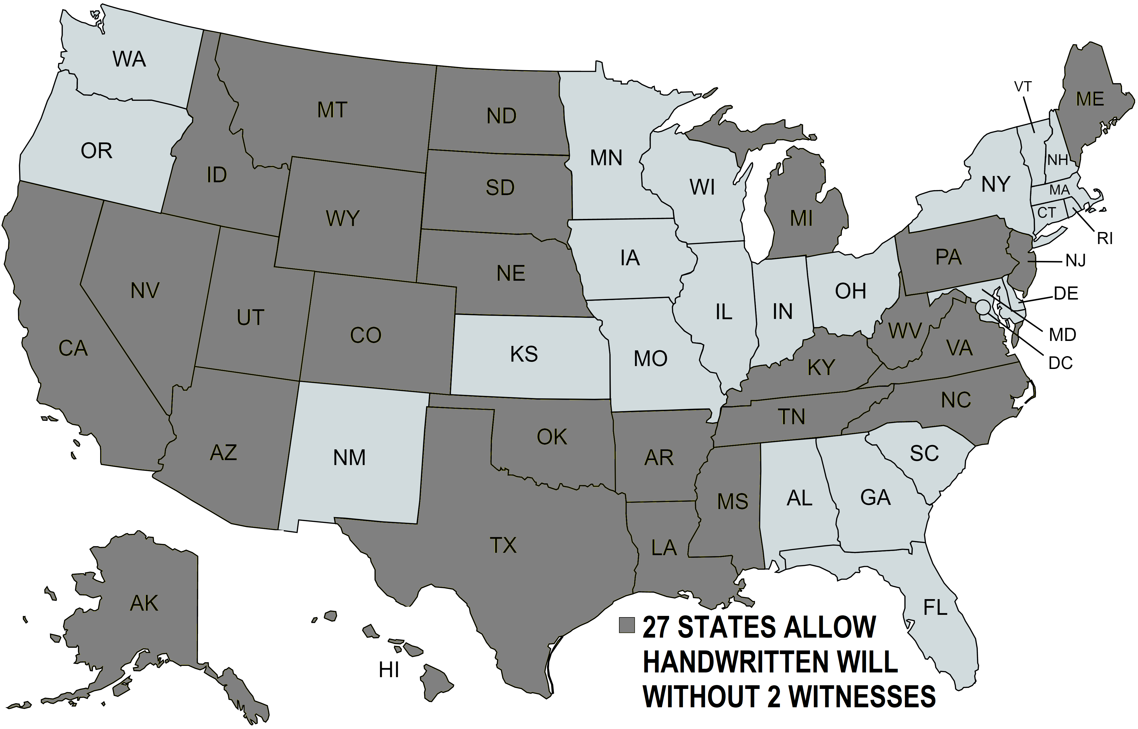

HANDWRITTEN WILLS ARE USUALLY FINE BUT REQUIRE LATER WORK
Some lawyers war n against Handwritten Wills saying they often read confusingly, skip legal words that help in some cases, and are found invalid more often – but some studies show they are liked and usually fine.
After a death to use a Handwritten Will some person must in writing or in testimony say the handwriting looks like the Testator, which can be a hassle to get. But a normal Will if no Self-Proving Affidavit was done also needs similar proof like from a witness to the signing or other proof of signing. Handwritten Wills tend to be done by people who are young so unlikely to need a Will soon, who are in a hurry, who want to fix a mistake, who before a trip want to pick a Guardian, who moved to a new state, or who plan to do a better Will later.

WORDS ON BOTTOM OF THIS PAGE CAN BE USED FOR A HANDWRITTEN WILL

People can do a Handwritten Will in a sentence that is legal but may leave out helpful parts, for example:
“As my Will I give my estate and all else to Ann Baker who shall be Executor . – Dan Baker ”

But it is recommended people use more complex words for a Handwritten Will shown on this page below.
To do this people should change the names and words below on this page to match what they want done.
The words below mainly say property and money goes to the persons whose names are written in the Will.
If some people named to get things later die it is usually best to re-do the Will and name different people.
The last paragraph about Guardians for children can be skipped if a person has no children under age 18.
This Will must be all handwritten and signed by person doing it on some paper, and using pencil is fine.

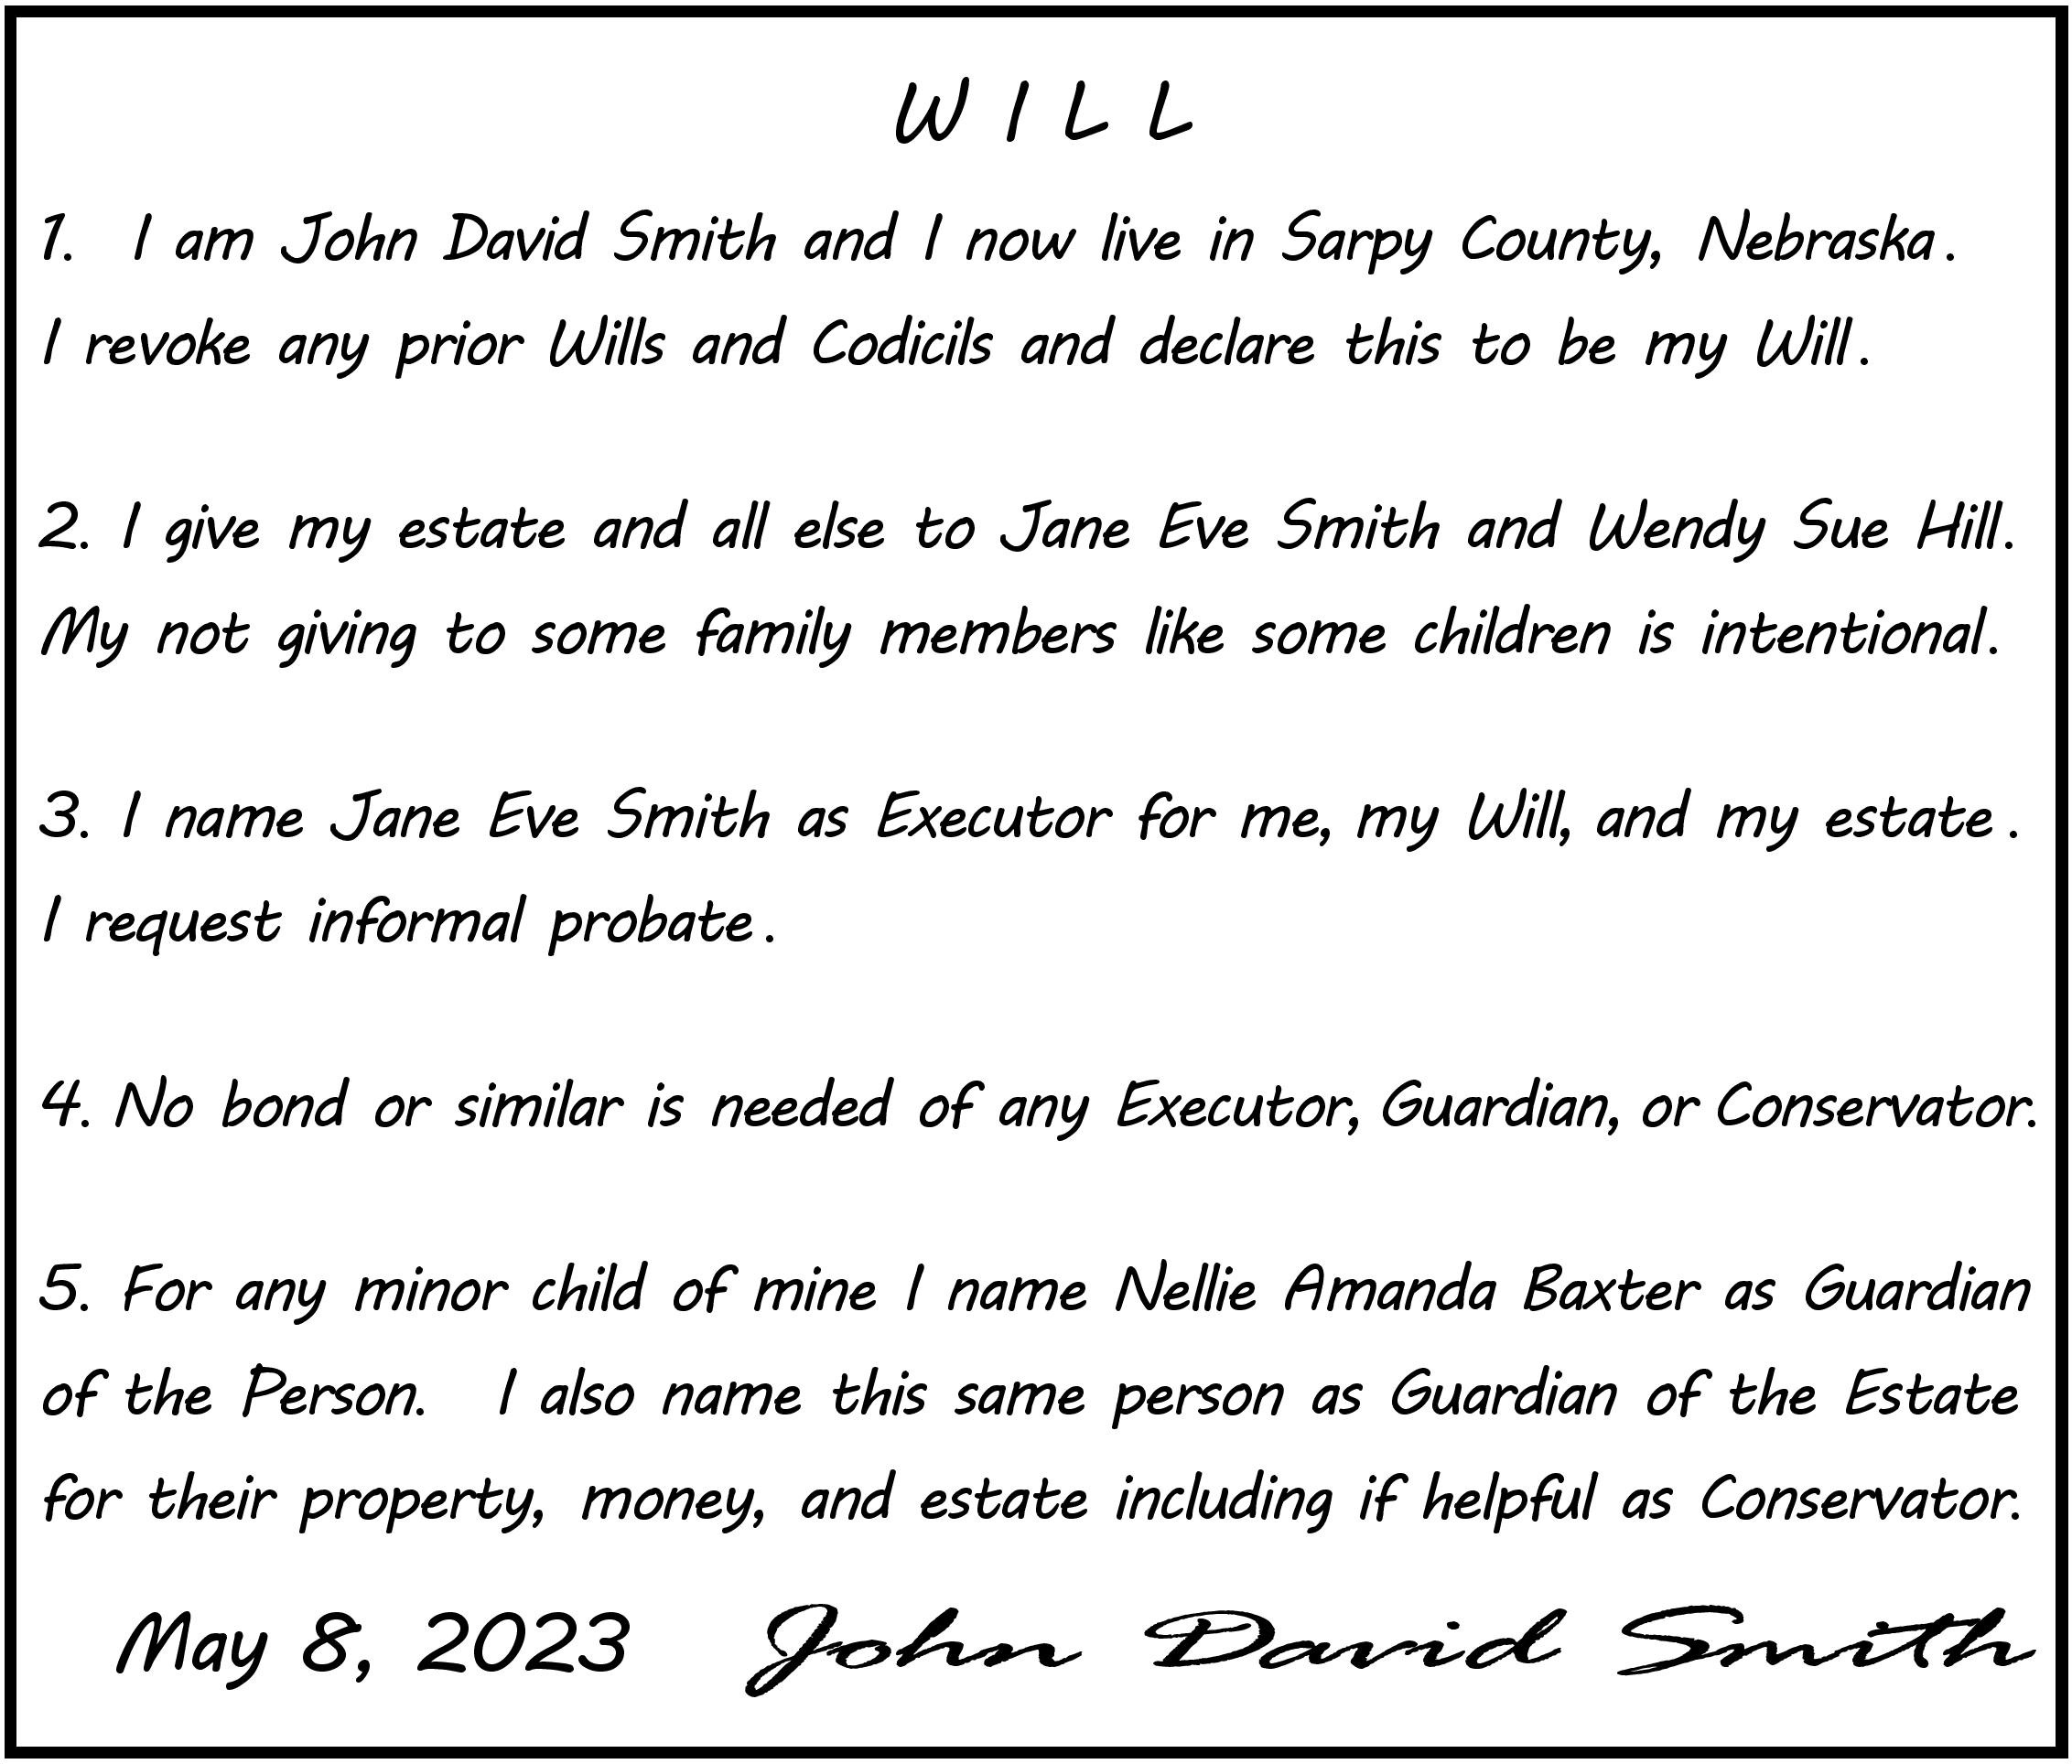
CHAPTER 12 ..FORM 6: HEALTH CARE POWER OF ATTORNEY

FORM CAN NAME HEALTH CARE AGENT AND GIVE INSTRUCTIONS
In case needed later this for m lets a person name someone to control health care and give instructions. This book’s for m is based on a statutory for m found in state law at Neb. Stat. § 30-3408, and then the Nebraska Supreme Court and the State Unit On Aging made a few changes and issued it as a standard for m. This for m is well known and can be filled in online on many state websites and then printed. To find this
for m a person can search online for Nebraska and name of a for m or can look at bottom of the page at https://dhhs.ne.gov/Pages/Aging-Client-Information.aspx . Nebraska also has a nice brochure online with many for ms called “Surrogate Decision Making” (“surrogate” means a person is doing an act for another, for example parents are surrogate decision makers for a child). This Health Care Power Of Attorney for m is often the only for m to control health care that people do.

FORM CAN NAME AGENT FOR HEALTH CARE AND GIVE INSTRUCTIONS
In the first part of the for m a person can be named as “Attorney In Fact” to control health care if later the person doing the for m is later incapacitated (like by inability to communicate, be conscious, or think rationally).
Often named as Attorney In Fact is a spouse, adult child, relative, or a friend. The person need not be a real Attorney or Lawyer to serve as Attorney In Fact. A second person (a “Successor”) can also be named to serve if the first person can’t serve for some reason but many people skip this since it is rarely needed.
A person naming an Attorney in Fact for health care can help avoid family or friends having to rush to a judge for power over health care if the person is later incapacitated. The Attorney In Fact usually should not be a worker or owner at a place giving health care.

FORM HAS SOME SPOTS TO INITIAL OR SKIP
In the for m are a few spots a person must initial or the for m will have no power. Also in the for m are optional spots a person can initial and write some instructions, however many people skip these parts and skip giving a lot of instructions. Many people skip most parts since they trust the wisdom of their named Attorney In Fact and family and, also, if instructions aren’t very clear it can cause delays and legal problems.

PERSON SIGNS FORM IN FRONT OF 2 WITNESSES OR A NOTARY
The for m should be signed by a person in front of 2 persons acting as witnesses who then also sign,
or instead of witnesses a notary can be used. Witnesses should be at least age 18 and can’t be directly involved in providing health care and can’t be named at Attorney In Fact in the for m. Once the for m
is done it is usually shown to places that may give care to put in a person’s medical file to be followed.
To cancel the for m a person usually tells their doctor and maybe tells any places that saw the for m.
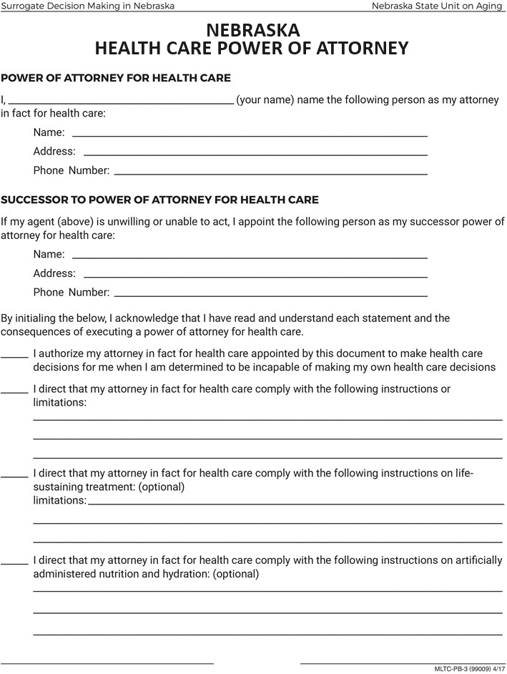

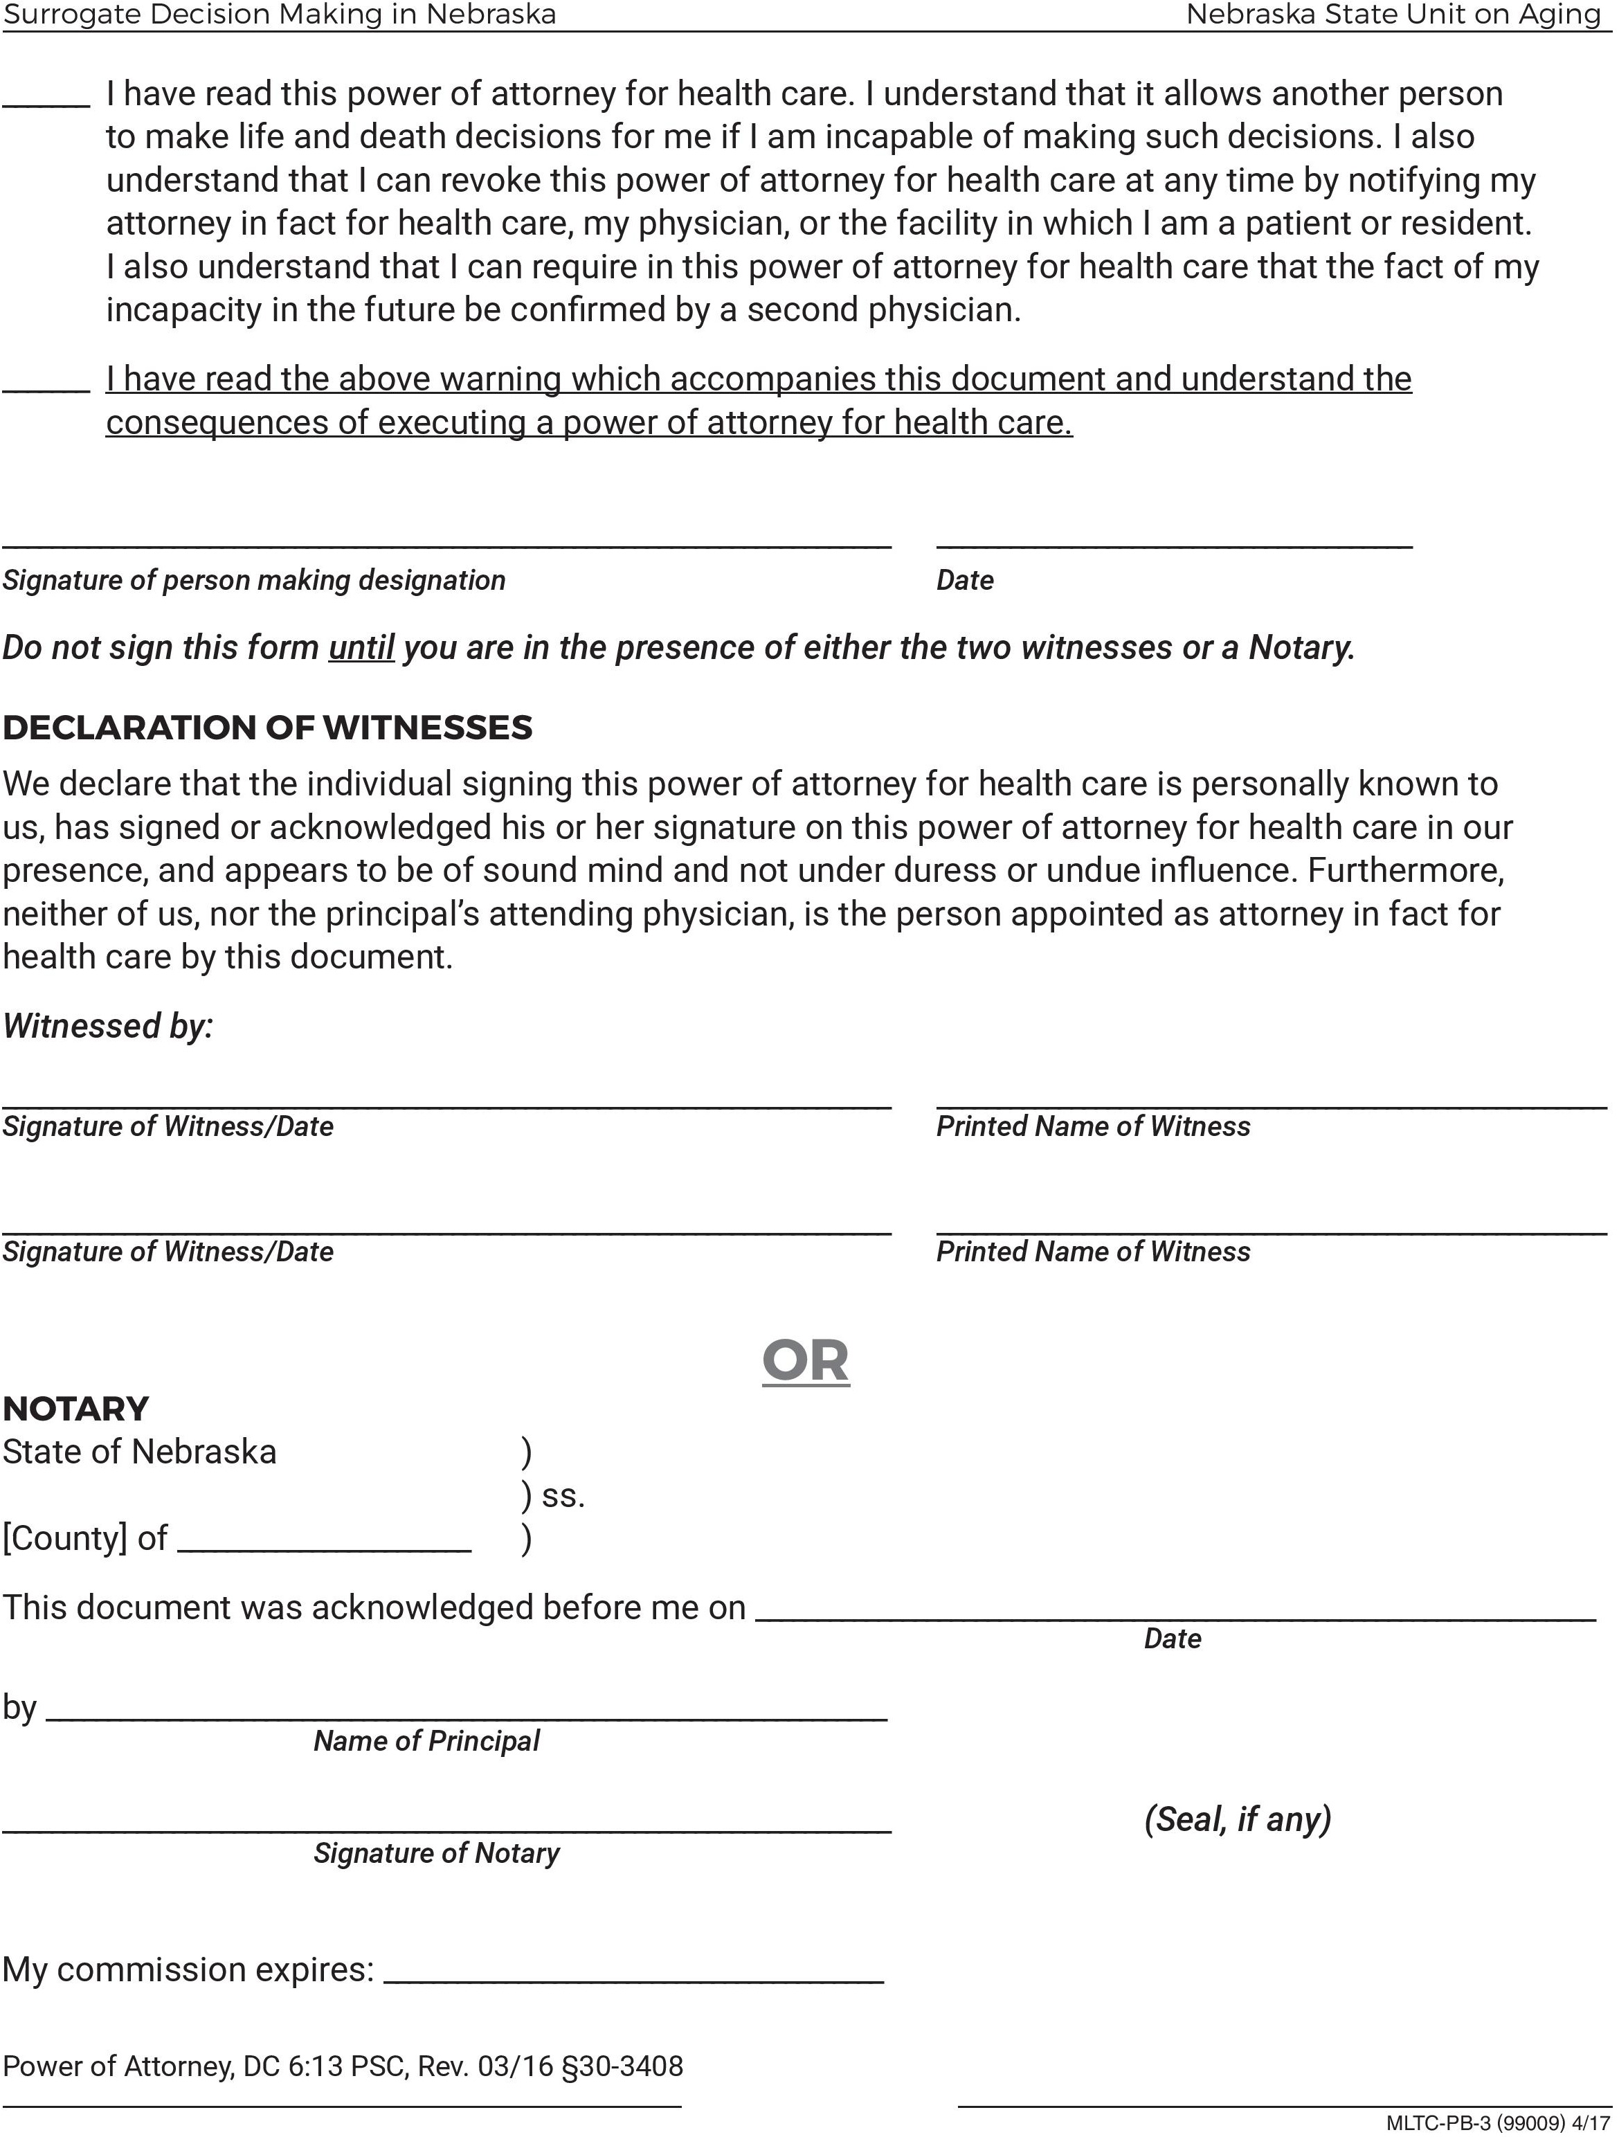
CHAPTER 13
FORM 7: LIVING WILL DECLARATION

IN FORM CAN SAY TO STOP CARE IF LATER DOCTORS THINK IT WON’T HELP
This for m lets a person do serious act of saying stop most health care if later doctors think the person is incapacitated and more health care almost certainly won’t help them. This book’s for m is based on the statutory for m from Neb. Stat. § 20-404, and then the Nebraska State Unit On Aging made a few small changes and issued this as a standard for m. This for m can be filled in online on many state webpages and then printed. To find a for m a person can search online for Nebraska and name of the for m or, alternatively, people can look at bottom of the page at https://dhhs.ne.gov/Pages/Aging-Client-Information.aspx .
Nebraska also has a nice brochure online called “Surrogate Decision Making” about this and similar for ms.

CAN STAY STOP MOST CARE IF LATER DOCTORS SAY IT LIKELY WON’T HELP
This for m lets a person do serious act of saying stop most health care if later doctors think the person is incapacitated and more health care almost certainly won’t help them. This for m is rarely done by people since this situation does not arise in all cases. Also many people trust their family or an Attorney In Fact
for health care they already named to consider all factors and decide when to stop care if this issue arises. The main part of the for m says:

If I should lapse into a persistent vegetative state or have an incurable and irreversible condition that, without the administration of life-sustaining treatment, will, in the opinion of my attending physician, cause my death within a relatively short time and I am no longer able to make decisions regarding my medical treatment, I direct my attending physicians […] to withhold or withdraw life-sustaining treatment that is not necessary for my comfort or to alleviate pain.”

PERSON SIGNS FORM IN FRONT OF EITHER NOTARY OR 1 WITNESS
The for m must be signed in front of either a person who is a notary who then notarizes the for m, or in front of 2 witnesses who then sign too. A person doing this for m can’t use as a witness anyone under 18, involved in providing health care to the sick person, or already named as Attorney In Fact for health care.
Once it is filled out and signed the for m usually is shown to all places that may give care to put in the person’s medical file to follow. To cancel the for m a person usually should clearly tell all places shown the for m that it is now canceled.

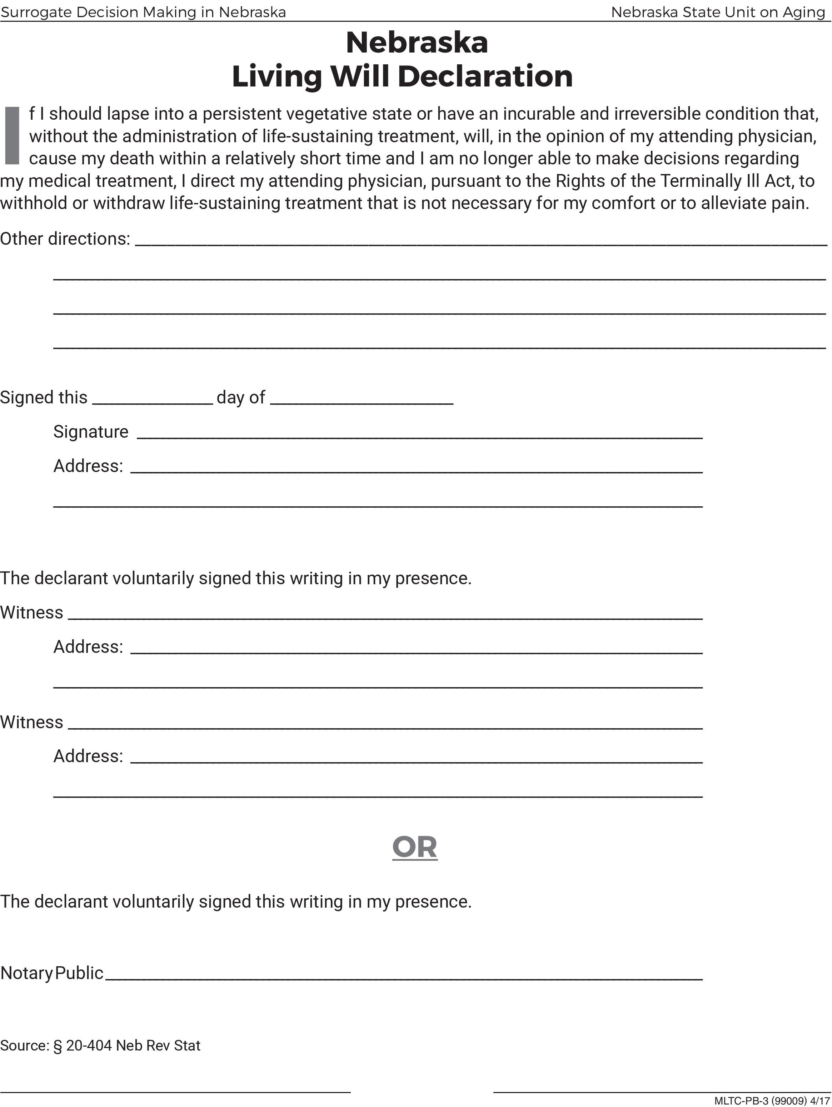

CHAPTER 14
FORM 8: DO NOT RESUSCITATE ORDER

FORM SAYS STARTING IMMEDIATELY DO NOT TRY TO RESUSCITATE
This for m lets a person say starting immediately do not try to resuscitate them to help if their breathing or heart stops or has problems. This for m is rarely used and usually only by the sickest or oldest people.
This for m is a standard for m from the Medical Services Oversight Authority which oversees paramedics and most first responders in Nebraska. The for m is short and can be read fast (like by paramedics) and is often used outside a hospital or other facilities (paramedics actually will ignore other for ms like a Living Will or a Health Care Power Of Attorney). This for m can be used in health facilities but usually these places prefer other for ms including their own hospital for ms which deal with what care a person wants.

FORM SAYS TO IMMEDIATELY NO LONGER TRY TO RESUSCITATE
In the for m a person can say starting immediately do not try to resuscitate the person, which includes
most kinds of treatments to re-start or help either breathing or the heart. This includes cardio-pulmonary resuscitation (C.P.R.) which is pushing chest and blowing air in lungs, electric shock to restart heart or get a stable heartbeat (defibrillation), and machines that help or force breathing. A person still thinking OK can override the for m by clearly verbally requesting care or by just not showing paramedics or others the for m.
Note, if a person has done this for m they are still usually taken to get pain relief and other comfort care.
This for m is rarely used and is usually only done by people with a terminal illness that likely will kill them within a year or so, or by people who due to having an illness are at risk of being unconscious for a long time. A doctor or similar must sign this for m and think a person’s health situation justifies doing the form.

PERSON SIGNS FORM AND THEN DOCTOR SIGNS FORM
The for m should be signed by the person doing the for m or someone with authority for them, and also signed by a doctor or similar person who agrees the for m is called for. Once done a for m usually is shown to places that may give health care so they can follow it. Some people keeps copies handy for themselves or family to show to paramedics and others who want try and give care. A copy of the for m might be kept on bedside table, on a fridge, pinned to a shirt or in a pocket, or some people wear a special bracelet doctors can help get. To cancel the for m usually a person simply tells places shown the for m it’s cancelled.

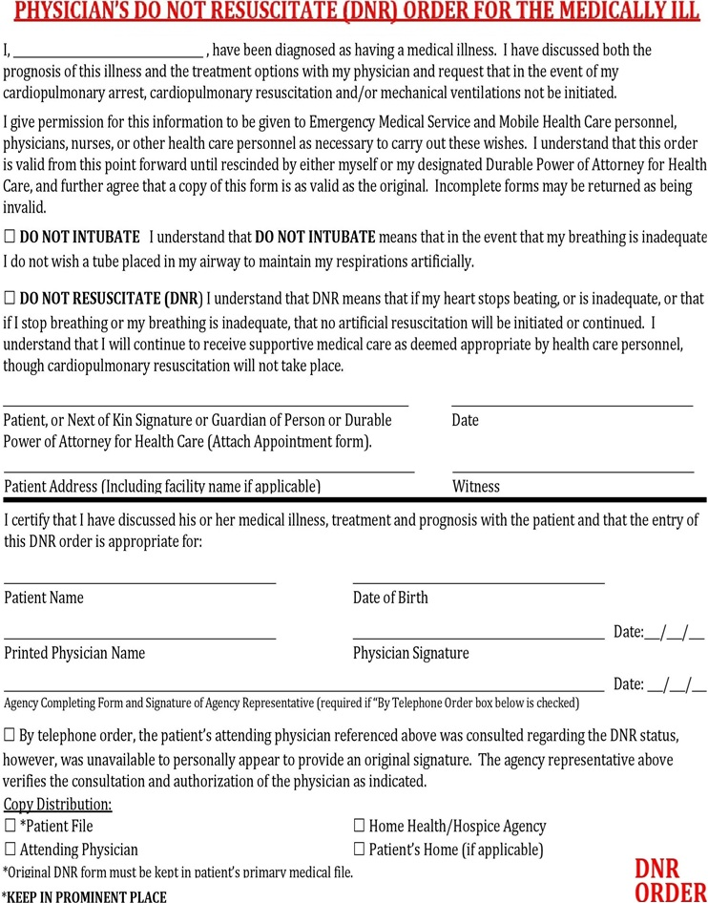
CHAPTER 15
FORM 9: STATUTORY FORM POWER OF ATTORNEY

FORM LETS POWER GO TO A PERSON OVER PROPERTY, MONEY, AND MORE

This for m lets a person share power with someone to do things with the person’s property, money, and other things. Many people call this for m a “Financial Power Of Attorney”. This book’s for m is based on the statutory for m found in law at Nebraska Statute § 30-4041, and then the Nebraska Supreme Court made a few changes and issued a standard form to use. This book’s for m includes the pages with infor mation at
the start and end that are part of the statutory for m and should be included but some people leave these off.

FORM GIVES POWER TO LET SOMEONE DO THINGS
This for m lets a person give power to do things with their money, property, records, and other things to someone trusted like a spouse, other family member, or a friend. The person giving power is usually called the “Principal”. The person getting power is usually called the “Agent” (also called the “Attorney in Fact”).
If a person is sick or busy this for m can let someone help pay bills, use accounts, buy or sell items, borrow, hire workers, sign contracts, see records, and more. This for m can avoid more serious legal options like a guardianship of an adult at court. A person who isn’t incapacitated can overrule or fire their Agent anytime. Instructions can be written but most people skip this since if instructions are unclear a bank or others may delay or refuse to obey an Agent. In the for m a person can helpfully say who’d they’d prefer if ever needed
to be Guardian of the Person to control their care, and Conservator to control their property and money.

IN FORM CAN SELECT NORMAL POWERS AND MORE RISKY POWERS TO GIVE
At the top of page 2 of the for m a person can check a box and initial to say which of more normal powers are given. In this part most people give all these powers (by initialing the “All Preceding Subjects” line) since they trust their Agent and if power is not clear a bank or others may delay or refuse do what Agent wants.
Then later in the form is the “Specific Authority” part, and in this part some more risky powers can be given and most people skip all these powers.

DUE TO RISKS MANY SKIP THIS FORM OR CONSULT A LAWYER
Many people skip this for m or first see a lawyer. Using this for m is risky and can lead to har m since the Agent can be wasteful with money, commit fraud or theft, by carelessness allow other har ms, or do worse.
A person acting as Agent has a duty to be loyal and act reasonably and can be sued for any harm, but they may later be out of money to pay. Usually banks and others can’t be blamed for obeying an Agent’s orders. The law is complex and basic acts may be fine for Agent like paying bills but some acts may be improper like making gifts, risky investments, or unusual acts. It is best if a person not their Agent does anything unusual.

PERSON SIGNS FORM IN FRONT OF A NOTARY
A person must sign the for m in front of a notary who then notarizes it. Once it is done some cautious people quickly show the for m to banks and similar to say they should follow it later. When an Agent signs anything it should be like, for example: “Ed Smith signing as Agent under a Power of Attorney for Ann Hill ”.
To cancel the for m people should tell the Agent and take back copies and maybe tell places shown the for m.
Some banks before acting may later ask the Agent to sign the for m found at Nebraska Statutes § 30-4042.

NEBRASKA
STATUTORY FORM POWER OF ATTORNEY
(Nebraska Revised Statute 30-4041)

THINGS TO KNOW BEFORE SIGNING A POWER OF ATTORNEY FORM:
IMPORTANT INFORMATION

This power of attorney authorizes another person (your agent) to make decisions concerning your property for you (the principal). Your agent will be able to make decisions and act with respect to your property (including your money) whether or not you are able to act for yourself. The meaning of authority over subjects listed on this form is explained in the Nebraska Uniform Power Of Attorney Act.

This power of attorney does not authorize the agent to make health care decisions for you.

You should select someone you trust to serve as your agent. Unless you specify otherwise, generally the agent's authority will continue until you die or revoke the power of attorney or the agent resigns or is unable to act for you.

This form will not revoke a power of attorney previously executed by you unless you add that the previous power of attorney is revoked or that all other powers of attorney are revoked by this power of attorney.

Your agent is entitled to reasonable compensation unless you state otherwise in the Special Instructions.

This form provides for designation of one agent. If you wish to name more than one agent, you may name a coagent in the Special Instructions. Coagents are not required to act together unless you include that requirement in the Special Instructions.

If your agent is unable or unwilling to act for you, your power of attorney will end unless you have named a successor agent. You may also name a second successor agent.

This power of attorney becomes effective immediately unless you state otherwise in the Special Instructions.

If you have questions about the power of attorney or the authority you are granting to your agent, you should seek legal advice before signing this form.

A brief explanation of the subjects which may be included under the Power of Attorney General Authorities are listed below, however, for a full definition of each subject, please see Nebraska Revised Statutes Chapter 30-4027 through Chapter 30-4040.

INTER VIVOS TRUST is generally an agreement appointing a trustee to receive assets for the person creating the trust and one or more beneficiaries (for a full definition, see Nebraska Revised Statutes Chapter 30-3881).

REAL PROPERTY generally includes land and structures attached to land (for a full definition, see Nebraska Revised Statutes Chapter 30-4027).

TANGIBLE PERSONAL PROPERTY generally includes property which can be physically identified and transferred (for a full definition, see Nebraska Revised Statutes Chapter 30-4028).

STOCKS AND BONDS generally do not include commodity futures contracts and call or put options on stocks or stock indexes (for a full definition, see Nebraska Revised Statutes Chapter 30-4029).

COMMODITIES AND OPTIONS generally do not include stocks and bonds (for a full definition, see Nebraska Revised Statutes Chapter 30-4030).

BANKS AND OTHER FINANCIAL INSTITUTIONS generally include trusts, savings and loans, credit unions, and brokerage institutions (for a full definition, see Nebraska Revised Statutes Chapter 30-4031).

OPERATION OF AN ENTITY OR BUSINESS generally includes contracts, insurance payments, collections, and tax responsibilities (for a full definition, see Nebraska Revised Statutes Chapter 30-4032).

INSURANCE AND ANNUITIES generally includes rights regarding benefits and responsibilities for premiums (for a full definition, see Nebraska Revised Statutes Chapter 30-4033).

ESTATES, TRUSTS, OR OTHER BENEFICIAL INTERESTS generally include guardianships and conservatorships (for a full definition, see Nebraska Revised Statutes Chapter 30-4034)

CLAIMS AND LITIGATION generally includes asserting and maintaining a claim before a court
or administrative agency (for a full definition, see Nebraska Revised Statutes Chapter 30-4035).

PERSONAL AND FAMILY MAINTENANCE generally includes maintaining the customary standard of living of the principal and principal’s family (for a full definition, see Nebraska Revised Statutes Chapter 30-4036).

BENEFITS FROM GOVERNMENTAL PROGRAMS OR CIVIL OR MILITARY SERVICE generally includes some retirement accounts (for a full definition, see Nebraska Revised Statutes Chapter 30- 4037).

RETIREMENT PLANS generally excludes certain benefits from governmental programs or civil military service (for a full definition, see Nebraska Revised Statutes Chapter 30-4038).

TAXES generally include federal, state, local, foreign income, gift, payroll, property, Federal Insurance Contributions Act, and other taxes (for a full definition, see Nebraska Revised Statutes Chapter 30- 4039).

WHAT TO DO WITH THE COMPLETED GENERAL POWER OF ATTORNEY FORM

Power of Attorney forms do not have to be filed with a court; however, it is very important to keep the form in a secure place where it will not be damaged. You should give a copy of the notarized power of attorney to your agent. Additionally, it is very important all people involved with the power of attorney form are aware of the location of the form, for future reference.

NOTE: Every power of attorney ends immediately upon death of the principal.

Nebraska Power of Attorney

DESIGNATION OF AGENT

I . . (your name) name the following person as my agent
(individual with power of attorney):

Agent:. .

Address: .

Telephone Number: .

DESIGNATION OF SUCCESSOR AGENT(S) (OPTIONAL)

If my agent is unable or unwilling to act for me, I name as my successor agent:

Name of Successor Agent:. .

Address: .

Telephone Number: .

RELEASE OF INFORMATION

I agree to, authorize, and allow full release of information, by any governmental agency, business, creditor, or third party who may have information pertaining to my assets or income, to my agent named on this form.

GRANT OF GENERAL AUTHORITY

I grant my agent and any successor agent general authority to act for me with respect to the following subjects (as defined in the Nebraska Uniform Power of Attorney Act):

(CHECK  Yes or  No AND initial for each of the subjects that follow. These subjects represent those you may want to include in the agent's general authority. If you wish to grant
general authority over all of the subjects you may check  Yes for "All Preceding Subjects"
AND initial that line instead of checking each subject.)

Check one: Initials:
 Yes  No _______ Real Property
 Yes  No _______ Tangible Personal Property
 Yes  No _______ Stocks and Bonds
 Yes  No _______ Commodities and Options
 Yes  No _______ Banks and Other Financial Institutions
 Yes  No _______ Operation of Entity or Business
 Yes  No _______ Insurance and Annuities
 Yes  No _______ Estates, Trusts, and Other Beneficial Interests
 Yes  No _______ Claims and Litigation
 Yes  No _______ Personal and Family Maintenance
 Yes  No _______ Benefits from Governmental Programs or Civil or Military Service
 Yes  No _______ Retirement Plans
 Yes  No _______ Taxes
 Yes  No _______ All Preceding Subjects (includes all items listed above)

GRANT OF SPECIFIC AUTHORITY (OPTIONAL)

My agent MAY do any of the following specific acts for me IF I have CHECKED the specific authority listed below:

(CAUTION: Granting any of the following will give your agent the authority to take actions that could significantly reduce your property or change how your property is distributed at your
death. CHECK YES AND INITIAL ONLY the specific authority you WANT to give your agent. NOTE: If you do not mark yes and initial the authority, the authority is not granted.)

Check one: Initials:
 Yes  No _______ Create, amend, revoke, or terminate an inter vivos trust
 Yes  No _______ Make a gift, subject to the limitations of the Nebraska Uniform
Power of Attorney Act and any special instructions in this power of attorney
 Yes  No _______ Create or change rights of survivorship
 Yes  No _______ Create or change a beneficiary designation
 Yes  No _______ Delegate to another person to exercise the authority granted
under this power of attorney
 Yes  No _______ Waive the principal's right to be a beneficiary of a joint
and survivor annuity, including a survivor benefit under a retirement plan
 Yes  No _______ Exercise fiduciary powers that principal has authority to delegate
 Yes  No _______ Renounce or disclaim an interest in property, including a
power of appointment.

LIMITATION ON AGENT'S AUTHORITY

If I did not check the “Power of Personal and Family Maintenance” or “All Preceding Subjects”
in the Grant of General Authority above, my agent MAY NOT use my property to benefit themselves or anyone they support except for those items listed below in the
Special Instructions.

SPECIAL INSTRUCTIONS (OPTIONAL)

You may give special instructions in the following space:
. . . .
. .
. .
. .
. .
. .
. .
. .
. .
. .

NOMINATION OF [CONSERVATOR OR GUARDIAN] (OPTIONAL)

If it becomes necessary for a court to appoint a conservator of my estate, I nominate the following person(s) for appointment:

Name of nominee for conservator of my estate:. .

Address: .

Telephone Number: .

If it becomes necessary for a court to appoint a guardian of my person, I nominate the following person(s) for appointment:

Name of nominee for guardian of my person:. .

Address: .

Telephone Number: .

RELIANCE ON THIS POWER OF ATTORNEY

Any person, including my agent, may rely upon the validity of this power of attorney or a copy of it unless that person knows it has terminated or is invalid.

EFFECTIVE DATE: This power of attorney is effective immediately unless I have stated otherwise in the special Instructions.

TERMINATION: I understand this power of attorney ends immediately upon my death.

SIGNATURE AND ACKNOWLEDGMENT….

(CAUTION: This document MUST be signed IN THE PRESENCE of a notary to comply with
the Nebraska Uniform Power of Attorney Act)

____________________________________________ ____________________________
Your Signature Date

. . . .
Your Name Printed Your Telephone Number

.
Your Address

NOTARY

State of Nebraska )
) ss.
County of _______________________ )

This document was acknowledged before me on . .
(Date)
by . .
(Name of Principal)

__________________________________ (Seal, if any)
Signature of Notary
My commission expires:_________________

IMPORTANT INFORMATION FOR AGENT

Agent's Duties
When you accept the authority granted under this power of attorney, a special legal relationship is created between you and the principal. This relationship imposes upon you legal duties that continue till you resign or the power of attorney is terminated or revoked. You must:
1. do what you know the principal reasonably expects you to do with the principal's property or, if you do not know the principal's expectations, act in the principal's best interest;
2. act in good faith;
3. do nothing beyond the authority granted in this power of attorney; and
4. disclose your identity as an agent whenever you act for the principal by writing or printing the name of the principal and signing your own name as "agent" in the following manner:
(Principal's Name) by (Your Signature) as Agent

Unless the Special Instructions in this power of attorney state otherwise, you must also:
1. act loyally for the principal's benefit;
2. avoid conflicts that would impair your ability to act in the principal's best interest;
3. act with care, competence, and diligence;
4. keep a record of all receipts, disbursements, and transactions made on behalf of the principal;
5. cooperate with any person that has authority to make health care decisions for the principal to do what you know the principal reasonably expects or, if you do not know the principal's expectations, to act in the principal's best interest; and
6. attempt to preserve the principal's estate plan if you know the plan and preserving the plan is consistent with the principal's best interest.

Termination of Agent's Authority
You must stop acting on behalf of the principal if you learn of any event that terminates this power of attorney or your authority under this power of attorney. Events that terminate a power of attorney or your authority to act under a power of attorney include:
1. death of the principal;
2. the principal's revocation of the power of attorney or your authority;
3. the occurrence of a termination event stated in the power of attorney;
4. the purpose of the power of attorney being fully accomplished; or
5. if you are married to the principal, a legal action filed with a court to end your marriage, or for your legal separation, unless the Special Instructions in this power of attorney state that such an action will not terminate your authority.

Liability of Agent
The meaning of the authority granted to you is defined in the Nebraska Uniform Power of Attorney Act. If you violate the Nebraska Uniform Power of Attorney Act or act outside the authority granted, you may be liable for any damages caused by your violation.

If there is anything about this document or your duties that you do not understand, you should seek legal advice.

OPTIONAL SIGNATURE OF AGENT

I HAVE READ AND ACCEPT THE DUTIES AND LIABILITIES OF THE AGENT AS SPECIFIED IN THIS POWER OF ATTORNEY.

Agent's Signature:________________________________ Date:______________________
CHAPTER 16
FORM 10: TEMPORARY DELEGATION OF PARENTAL POWERS

FORM LETS PARENT SHARE POWER WITH SOMEONE OVER CHILD UNDER 18
This for m lets a parent of a child under age 18 share power over them with someone named in the for m. This book’s for m is the well known for m by the Nebraska Supreme Court for people to use if they ever want.
The Nebraska Supreme Court discusses this for m and has a version of the for m that can be filled in online at https://supremecourt.nebraska.gov/self-help/families-children/temporary-delegation-parental-powers.

FORM CAN GIVE POWER TO SOMEONE OVER CHILD UNDER 18
In the for m a parent or also a legal custodian can share some power over a child under 18 to a person they name. The person who did the for m can usually fire the person they named or overrule any decision.
Often given power is a relative, friend, or teacher who may watch a child for a parent. This for m is sometimes used if a parent and child are separated for work, school, training, drug rehab, sports, prison, military, immigration, or long visits. The for m is mostly not done for brief or normal situations like daycare, babysitter, short visits, or anytime a parent can come quickly. This for m can avoid need for more serious legal actions like foster care. Power over adoption, marriage, abortion, and termination of parental rights can’t be given by this for m. This for m is only effective for 6 months and then people can re-do the for m.

FORM IS SIGNED BY A PARENT IN FRONT OF A NOTARY
The for m must be signed by a parent in front of a notary who then notarizes the for m. Some people change the for m to add room for a 2nd parent to sign to make it likelier people like doctors and teachers trust the for m. Some extra cautious people quickly show the for m to schools and doctors to help explain they should follow it later. Once signed usually a parent gives the for m to the person getting power to use whenever it is needed. To cancel things a person should take back copies of the for m and maybe tell any places that were shown the for m that it is now canceled.

TEMPORARY DELEGATION OF PARENTAL POWERS

I,___________________________________ of _____________________________,
(your full name) (city where you reside)
Nebraska, do make and appoint __________________________________________ of
(full name of person being appointed)

_____________________________________________________, to act for me and in
(address, city and state where person being appointed resides)
my name to exercise all my powers regarding the care, custody and property of

_____________________________________, born ____________________________,
(child’s full name) (child’s date of birth)
except my power to consent to marriage and adoption of the child. I hereby give

_____________________________________ full authority and power to do everything
(full name of person being appointed)

necessary to be done, as fully as I could or might do if personally present, for a period
not exceeding six months beyond this date. I confirm and ratify all lawful acts done, or

caused to be done by __________________________________ acting under this
(full name of person being appointed)
Delegation of Powers regarding the care, custody and property of my child.

This Delegation of Parental Powers may be revoked by me at any time before the

expiration of this six-month period by written notice to ___________________________
(full name of person being appointed)
at the address above.

Signature:________________________________ Date:________________________
Printed Name:______________________________ Phone:_____________________
Street Address/P.O. Box:__________________________________________________
City/State/ZIP Code:____________________________ Email:____________________

State of Nebraska )
) ss.
County of ________________ )

The foregoing instrument was acknowledged before me by _____________________,
(Name of person certifying above)

this _______ day of _____________, 20____.
(Day) (Month) (Year) . ccccccccccccccccccccccccccccccccccccccccccccccccccccccccSigned:__________________________
(signature of person taking acknowledgment)

___________ ______________ My commission expires:_____________
(title or rank) (serial number, if any)

Temporary Delegation
D C 6: 10. 1 Rev. 06/2019 Page 1 of 1 of Parental Powers

CHAPTER 17
FORM 11: AUTHORIZING AGENT AFFIDAVIT FOR REMAINS

LETS PERSON BE NAMED AND INSTRUCTIONS GIVEN TO HANDLE DEAD BODY
This for m lets someone be named and instructions be given by a person to control their body after death (their “remains”) and related things like funeral, burial, cremation, ceremonies, and buying things for all this.
This book’s for m is a statutory for m found at Nebraska Statutes § 30-2223.

FORM CAN NAME PERSON TO CONTROL DEAD BODY AND RELATED ISSUES
This for m lets a person designate someone as their Agent to control the person’s dead body and
all related issues like funeral, burial, cremation, ceremonies, and buying goods and services for all this.
If this for m is not done under state law control of all this is by the closest family member (in order this means a spouse, adult children, parents, then siblings). People do this for m rarely, mostly only if it seems family may be too upset while mourning, be bad with money, or do unwanted things. Payment for all these things comes from pre-paid funeral accounts, insurance, and a dead person’s money and property, and family and A person’s Executor and family are legally required to arrange payment to do as the dead person wanted if the dead person left enough money and property to afford it. No matter who is in charge they legally should do what the dead person wanted done with their remains so long as the dead person’s estate can afford it.

FORM CAN GIVE INSTRUCTIONS THAT EVERYONE MUST FOLLOW
The for m also has an optional spot for instructions like saying what funeral, burial, cremation, tombstone, ceremonies, songs, scriptures, pastors, food, and other things are wanted or already paid for. Or a person can attach pages of paper with these instructions. These instructions should be followed by everyone so long as the dead person’s estate can afford it. However many people skip giving any instructions and
they just trust the person they named in the for m or their family to do what they mentioned they wanted.
In recent years more and more people write they want “Direct Burial” or “Direct Cremation”, and this is an affordable option done fast in a few days and without family watching, and later family often hold an infor mal event (often called a “Celebration Dinner” ) either without the body at all or when family later get the ashes
or can visit the grave. About half of people now do cremation which is more affordable than burial.

PERSON SIGNS FORM IN FRONT OF A NOTARY
A person should sign the for m in front of a person who is a notary who then notarizes it. Once done
the for m can be given to someone to hold and use when needed, or it can be put in a place where it can be found quickly within just a few days of a death (like in a file cabinet, a safe, or desk drawer).

AUTHORIZING AGENT AFFIDAVIT FOR REMAINS

( Nebraska Revised Statute 30-2223 )

State of Nebraska )
) ss.
County of __________________ )

I, _______________________________________ (name of person executing this affidavit) do

hereby designate _________________________________________ (name of person designated) with the right to control the disposition of my remains upon my death (including the right to control the disposition of the remains of a deceased person, the location, manner, and conditions of disposition, and the arrangements for funeral goods and services to be provided).
I _______ HAVE _______ HAVE NOT (check one option) attached or written below specific directions concerning the disposition of my remains which the designee shall substantially comply with, so long as such directions are lawful and there are sufficient resources in my estate to carry out the directions.
This affidavit does not constitute a durable power of attorney for health care.

Directions (Optional): ____________________________________________________________ ______________________________________________________________________________ ______________________________________________________________________________ ______________________________________________________________________________ ______________________________________________________________________________ ______________________________________________________________________________ ______________________________________________________________________________ ______________________________________________________________________________
(put directions for funeral, cremation, ceremonies, burial, and related matters on the lines above or firmly attach pages with this information).

_____________________________________________
SIGNATURE OF PERSON EXECUTING AFFIDAVIT

Notary:

Subscribed and sworn to before me this _______ day of

the month of __________________ of the year 20_____.

__________________________________
SIGNATURE OF NOTARY

My commission expires:______________

APPENDIX: SAMPLE FILLED OUT FORMS

TO GET FORMS to use PEOPLE CAN:
(1) photocopy book pages,
(2) tear out pages from a book, or
(3) download book with forms from www.davenportpublishing.com
AND USUALLY PDF FORM AT IS BEST TO AVOID SPACING/FORMAT CHANGES.

email any comments to davenportpress@gmail.com .

On the next pages to show how it can be done are some sample filled out legal for ms.

People can add words to legal for ms by computer or typewriter to be neater, but many people just by hand use pen, marker, or pencil to handwrite words into for ms.

It is not required but is bit better if signatures are in ink or marker not pencil.

Many parts of the for ms especially Will gifts can be left empty and unfilled.

Anyone can fill in words in legal for m not just the person doing the for m, like a friend with neat writing can fill in all the words, addresses, and dates that are needed.
Only the final signatures must be done by each person who wants the for m.

To add words in for m by pen, pencil, typewriter, or computer any of these is fine:

"I appoint John Doe as Agent" ,
"I appoint John Doe as Agent",
“I appoint John Doe as Agent".

When doing for ms it may help to know “respectively” means “in order just stated”.

People need not worry about neatness or small mistakes, and a document is usually fine if those people who knew a decedent in life can tell the likely meaning.

Sample Filled Out Form : Last Will and Testament (Standard)
with Gifts section skipped to not bother making small gifts

LAST WILL AND TESTAMENT

I, Paul Samuel Maxwell , of Buffalo County , Nebraska, do revoke all prior Wills and testamentary documents and do make, publish, and declare this as my Will.
I am of sound mind and under no duress or undue influence and acting voluntarily.

1. GIFTS. I give these gifts in this Will, but to get a gift in this section the recipient must survive me except as otherwise stated below.

I give ______________________________________ to ______________________.

I give ______________________________________ to ______________________.
I give ______________________________________ to ______________________.
I give ______________________________________ to ______________________.
I give ______________________________________ to ______________________.
I give ______________________________________ to ______________________.
I give ______________________________________ to ______________________.
I give ______________________________________ to ______________________.
I give ______________________________________ to ______________________.
I give ______________________________________ to ______________________.

2. SEPARATE WRITINGS. I may do writings separate from this Will to gift tangible personal property as allowed by state law, and all such writings should be followed.
But any such writing not found within 90 days of my death is canceled and has no effect.
A gift in such a writing to a person who does not survive me is canceled and has no effect.
This Will does not revoke any such writings that now exist.

3. RESIDUE. I give the rest and residue and remainder of my estate, my money and property of any kind and nature, and anything I have an interest in so long as it was not transferred by other Will provisions (all of which is called the “residue”), as follows:

a) to Susan Lee Maxwell who survive me with persons just named who
survive me taking the share of non-survivors, then

b) toS Oscar David Maxwell and Jennifer Judy Tabor and if any of those just named do not survive me their part goes to their lineal descendants, per stirpes.

4. ADMINISTRATION. I nominate and appoint Susan Lee Maxwell as Personal Representative including for me, my Will, and my estate.

5. MISCELLANEOUS. The following applies to this Will and generally.
In this document no unfilled part is a mistake and residue spaces may be left blank.
The facts support and Testator wants Nebraska law to apply to this Will and Testator.
Priority of Will gifts of the same type is based on the order they are written.
If a gift or section in this Will reasonably mentions survival in any way then such survival is an absolute condition and anti-lapse laws or similar have no effect.
The words “give” and “gift” also means a devise, bequest, grant, legacy, or similar.
A gift of property no longer owned by me at death shall lapse and be of no effect including no payment of money shall be done in its place, and all without ademption.
Unless a Will gift specifies otherwise if a Will gift goes to multiple recipients if any
do not survive me their part to them lapses and instead goes to other surviving recipients.
I am intentionally not providing more by Will or other ways for some family, including my children or their issue, and this is intentional and not a mistake or omission to remedy.
No gift or transfer I made during my life to a person reduces or offsets a Will gift, unless during my life I expressly usually called it a loan or an advancement.
Unless another meaning is shown use of plural includes the singular and vice versa, “they” can mean 1 person, and masculine, feminine, and neuter words are interchangeable.
Unless a Will specifically says otherwise a) a secured debt including a mortgage or lien shall not be paid off including by a Personal Representative or in probate, b) a recipient of a Will gift of property takes it subject to debts, and c) no Will gift recipient who later loses property gifted to them to a debtor or who pays to avoid foreclosure or other loss may require the estate or anyone to pay recipient back, do exoneration, or do or pay anything.
I give any Personal Representative the a) fullest authority, discretion, and powers allowed by state law, b) power to lease, sell, mortgage, convey, or keep property including real property in a manner and time they deem helpful or proper, and c) authority to settle
or pay claims or debts as they in their sole discretion choose. Any Personal Representative is given all powers that may be given to or held by them by law.
A Personal Representative paying costs or expenses of my estate should be repaid these.
Any Personal Representative has sole discretion how to divide a gift to several persons, how to carry out a general gift, and how to do a gift to multiple persons.
No lawyer hired by a Personal Representative should get a standard fee or percentage.
Any Conservator, Custodian, or similar person managing a minor’s property or money may use or invade the principal, sell property, and do any other action without court action.
If context permits the terms Personal Representative and Executor and Administrator are interchangeable, Guardian of the Estate and Conservator and Guardian of Property and
Custodian are interchangeable, and residue and residuary are interchangeable.
The residue includes lapsed or failed gifts, insurance paid to the estate, any inheritances
owed, and property I have or had a power of appointment or testamentary disposition over.

Any Personal Representative, Executor, Administrator, Guardian of any type like for
a person or estate, Conservator, Custodian, and any other fiduciary under this Will or otherwise shall qualify and serve without bond, surety, security, surety bond, or similar.
If evidence does not show it likely a person survived me by 120 hours (5 days) then for this Will and my estate they shall be deemed in all ways as having died before me.
Any Personal Representative may at any time transfer money or property of a minor under age 18 to a Custodian to serve under the Nebraska Uniform Transfers to Minors Act or a similar law anywhere, and they may pick the Custodian including themselves.

TESTATOR

_;;;;;
IN WITNESS WHEREOF now do I, Paul Samuel Maxwell , the Testator, sign my name to this instrument this 22nd day of June , 2022 , and being first duly sworn if any authority is shown below, do hereby declare to the undersigned authority and declare for all other purposes that I sign and execute this instrument as my Will and that I sign it willingly, that I execute it as my free and voluntary act for the purposes therein expressed and that I am 18 years of age or older or am not at this time a minor, and am of sound mind and under no constraint or undue influence.
Paul Samuel Maxwell Testator Signature

WITNESSES

We, Eve Mable Rogers and Mary Ann Moon, the Witnesses, sign our names to this
instrument, being first duly sworn and do hereby declare to the undersigned authority if any authority is shown below, and declare for all other purposes that the Testator signs and executes this instrument as Testator’s Will and signs it willingly, and that Testator executes it as Testator’s free and voluntary act for the purposes therein expressed, and that each of us in the presence and hearing of the Testator hereby signs this Will as witness to
the Testator's signing, and that to the best of our knowledge the Testator is 18 years of age
or older or is not a minor, and is of sound mind and under no constraint or undue influence.

Eve Mable Rogers l .
Witness Signature

1 Eve Mable Rogers, 14 2nd St., North Platte, NE 68105 . .Name and Residence of Witness (printed)

Mary Ann Moon
Witness Signature
Mary Ann Moon, 35 Buffalo Road, Broken Arrow, NE 68101 1
Name and Residence of Witness (printed)

Sample Filled Out Form : Last Will and Testament (Standard)
with Many Specific Gifts and with Residue Clause Given By Percentages

LAST WILL AND TESTAMENT

I, Paul Brian Kent , of . Douglas County , Nebraska, do revoke all prior
Wills and testamentary documents and do make, publish, and declare this as my Will.
I am of sound mind and under no duress or undue influence and acting voluntarily.

1. GIFTS. I give these gifts in this Will, but to get a gift in this section the recipient must survive me except as otherwise stated below.

I give . big oak table to Anne J. Smith .

I give . $5,000 .to . Loretta Marsha Baxter .

I give . 63 Ivy Road, Grand Isle, Nebraska to. Kenneth Alan Ford .

I give . all real property and fixtures I own in Lancaster County, Nebraska to.
Amy Marie Fox and Pamela Sue Fox .

I give . 903 Iceberg Road, Anchorage, Alaska to. James Eric Hanson .

I give. Bronze Roman Lamp to Anne Kilby and Kevin Kilby.

I give. wedding ring and 1998 Ford Truck .to Ruth Jones.

I give. all jewelry not given above l to . Kay Baxter and Mary Baxter ..

I give . $781.35 . to. Mary Natalie Swanson .

I give . Wells Fargo acct ending in #8923 3to . Lawrence Deer a hunting buddy ..

I give. all spare tires and auto parts .to . Victor Perez my mechanic .
I give $1000 .to each of my grandchildren so this will be about $10,000 in total .

2. SEPARATE WRITINGS. I may do writings separate from this Will to gift tangible personal property as allowed by state law, and all such writings should be followed.
But any such writing not found within 90 days of my death is canceled and has no effect.
A gift in such a writing to a person who does not survive me is canceled and has no effect.
This Will does not revoke any such writings that now exist.

3. RESIDUE. I give the rest and residue and remainder of my estate, my property, and money of any kind and nature, and all I have (all of which is called the “residue”), as follows:

a) to Ruth May Kent my wife e who survive me with persons just named who survive me taking the share of non-survivors, then

b) to 45% to Oscar Elliot Kent my son, and 45% to Karen Lisa Lundy my daughter, and 10% to Oscar Sanchez my friend and if any of those just named do not survive me their part goes to their lineal descendants, per stirpes.

4. ADMINISTRATION. I nominate and appoint Ruth May Kent my wife e as Personal Representative including for me, my Will, and my estate.

5. MISCELLANEOUS. The following applies to this Will and generally.
In this document no unfilled part is a mistake and residue spaces may be left blank.
The facts support and Testator wants Nebraska law to apply to this Will and Testator.
Priority of Will gifts of the same type is based on the order they are written.
If a gift or section in this Will reasonably mentions survival in any way then such survival is an absolute condition and anti-lapse laws or similar have no effect.
The words “give” and “gift” also means a devise, bequest, grant, legacy, or similar.
A gift of property no longer owned by me at death shall lapse and be of no effect including no payment of money shall be done in its place, and all without ademption.
Unless a Will gift specifies otherwise if a Will gift goes to multiple recipients if any
do not survive me their part to them lapses and instead goes to other surviving recipients.
I am intentionally not providing more by Will or other ways for some family, including my children or their issue, and this is intentional and not a mistake or omission to remedy.
No gift or transfer I made during my life to a person reduces or offsets a Will gift, unless during my life I expressly usually called it a loan or an advancement.
Unless another meaning is shown use of plural includes the singular and vice versa, “they” can mean 1 person, and masculine, feminine, and neuter words are interchangeable.
Unless a Will specifically says otherwise a) a secured debt including a mortgage or lien shall not be paid off including by a Personal Representative or in probate, b) a recipient of a Will gift of property takes it subject to debts, and c) no Will gift recipient who later loses property gifted to them to a debtor or who pays to avoid foreclosure or other loss may require the estate or anyone to pay recipient back, do exoneration, or do or pay anything.
I request and authorize any informal, summary, and quick probate or similar action.
Any Personal Representative may act independently with no supervision of any court, including independent administration, and with no inventory, appraisal, or other action.
A Personal Representative paying costs or expenses of my estate should be repaid these.
Any Personal Representative has sole discretion how to divide a gift to several persons, how to carry out a general gift, and how to do a gift to multiple persons.
Any Conservator, Custodian, or similar person managing a minor’s property or money may use or invade the principal, sell property, and do any other action without court action.
If context permits the terms Personal Representative and Executor and Administrator are interchangeable, Guardian of the Estate and Conservator and Guardian of Property and Custodian are interchangeable, and residue and residuary are interchangeable.
The residue includes lapsed or failed gifts, insurance paid to the estate, any inheritances

owed, and property I have or had a power of appointment or testamentary disposition over.
Any Personal Representative, Executor, Administrator, Guardian of any type like for
a person or estate, Conservator, Custodian, and any other fiduciary under this Will or otherwise shall qualify and serve without bond, surety, security, surety bond, or similar.
If evidence does not show it likely a person survived me by 120 hours (5 days) then for this Will and my estate they shall be deemed in all ways as having died before me.
If part of this Will is by law invalid or unenforceable other provisions remain in effect.
Any Personal Representative may at any time transfer money or property of a minor under age 18 to a Custodian to serve under the Nebraska Uniform Transfers to Minors Act or a similar law anywhere, and they may pick the Custodian including themselves.

TESTATOR

_;;;;;
IN WITNESS WHEREOF now do I, Paul Brian Kent , the Testator, sign my name to this instrument this 30th day of December , 2019 , and being first duly sworn if any authority is shown below, do hereby declare to the undersigned authority and declare for all other purposes that I sign and execute this instrument as my Will and that I sign it willingly, that I execute it as my free and voluntary act for the purposes therein expressed and that I am 18 years of age or older or am not at this time a minor, and am of sound mind and under no constraint or undue influence.
Paul Brian Kent
Testator Signature

WITNESSES
We, Olivia Joy Pawlenty and Roy Felix Pawlenty , the Witnesses, sign our names to this instrument, being first duly sworn and do hereby declare to the undersigned authority if any authority is shown below, and declare for all other purposes that the Testator signs and executes this instrument as Testator’s Will and signs it willingly, and that Testator executes it as Testator’s free and voluntary act for the purposes therein expressed, and that each of us in the presence and hearing of the Testator hereby signs this Will as witness to
the Testator's signing, and that to the best of our knowledge the Testator is 18 years of age
or older or is not a minor, and is of sound mind and under no constraint or undue influence.

Olivia Joy Pawlenty .
Witness Signature
Olivia Joy Pawlenty, 87 Forest Road, Hazzard, NE 68501 .
Name and Residence of Witness (printed)

Roy Felix Pawlenty .
Witness Signature
Roy Felix Pawlenty, 87 Forest Road, Hazzard, NE 68501 1
Name and Residence of Witness (printed)
Sample Filled Out Form : Last Will and Testament (Guardian)
with Gifts Section Shortened, Guardian named, and
Will modified to have a 1 Part Residue Clause

LAST WILL AND TESTAMENT

I, David Eric Smith , of Sarpy County , Nebraska, do revoke all prior Wills and testamentary documents and do make, publish, and declare this as my Will.
I am of sound mind and under no duress or undue influence and acting voluntarily.

1. GIFTS. I give these gifts in this Will, but to get a gift in this section the recipient must survive me except as otherwise stated below.

I give $500 to each one of my brothers, sisters, and cousins which will be about $20,000 in total .

I give $4000 to Worthington Food Shelf in West Lincoln, Nebraska .

2. SEPARATE WRITINGS. I may do writings separate from this Will to gift tangible personal property as allowed by state law, and all such writings should be followed.
But any such writing not found within 90 days of my death is canceled and has no effect.
A gift in such a writing to a person who does not survive me is canceled and has no effect.
This Will does not revoke any such writings that now exist.

3. RESIDUE. The rest and residue and remainder of my estate, my property of any kind and nature, and anything I have an interest in, I give to Adam Michael Smith and
Ann Sue Baker who survive me and to lineal descendants per stirpes of a person just named who did not survive me.

4. ADMINISTRATION. I nominate and appoint Ann Sue Baker as Personal Representative including for me, my Will, and my estate.

5. GUARDIAN. I hereby name Stephanie Ann Frankowski to be if needed the Guardian of any minor child of mine to have care, authority, control, custody, and other control of them (including as Guardian of the Person). I also name this same person to be
if needed Guardian for any minor child of mine or other minor person to have care, control, and power over their property, money, and estate (including as Guardian of the Estate).
Any person acting as a Guardian I also name to act as Conservator for a minor and their estate, property, and money if this is helpful.

6. MISCELLANEOUS. The following applies to this Will and generally.
In this document no unfilled part is a mistake and residue spaces may be left blank.
The facts support and Testator wants Nebraska law to apply to this Will and Testator.
Priority of Will gifts of the same type is based on the order they are written.
If a gift or section in this Will reasonably mentions survival in any way then such survival is an absolute condition and anti-lapse laws or similar have no effect.
The words “give” and “gift” also means a devise, bequest, grant, legacy, or similar.
A gift of property no longer owned by me at death shall lapse and be of no effect including no payment of money shall be done in its place, and all without ademption.
Unless a Will gift specifies otherwise if a Will gift goes to multiple recipients if any
do not survive me their part to them lapses and instead goes to other surviving recipients.
I am intentionally not providing more by Will or other ways for some family, including my children or their issue, and this is intentional and not a mistake or omission to remedy.
No gift or transfer I made during my life to a person reduces or offsets a Will gift, unless during my life I expressly usually called it a loan or an advancement.
Unless another meaning is shown use of plural includes the singular and vice versa, “they” can mean 1 person, and masculine, feminine, and neuter words are interchangeable.
Unless a Will specifically says otherwise a) a secured debt including a mortgage or lien shall not be paid off including by a Personal Representative or in probate, b) a recipient of a Will gift of property takes it subject to debts, and c) no Will gift recipient who later loses property gifted to them to a debtor or who pays to avoid foreclosure or other loss may require the estate or anyone to pay recipient back, do exoneration, or do or pay anything.
I request and authorize any informal, summary, and quick probate or similar action.
Any Personal Representative may act independently with no supervision of any court, including independent administration, and with no inventory, appraisal, or other action.
I give any Personal Representative the a) fullest authority, discretion, and powers allowed by state law, b) power to lease, sell, mortgage, convey, or keep property including real property in a manner and time they deem helpful or proper, and c) authority to settle
or pay claims or debts as they in their sole discretion choose. Any Personal Representative is given all powers that may be given to or held by them by law.
A Personal Representative paying costs or expenses of my estate should be repaid these.
Any Personal Representative has sole discretion how to divide a gift to several persons, how to carry out a general gift, and how to do a gift to multiple persons.
No lawyer hired by a Personal Representative should get a standard fee or percentage.
Any Conservator, Custodian, or similar person managing a minor’s property or money may use or invade the principal, sell property, and do any other action without court action.
If context permits the terms Personal Representative and Executor and Administrator are interchangeable, Guardian of the Estate and Conservator and Guardian of Property and Custodian are interchangeable, and residue and residuary are interchangeable.
The residue includes lapsed or failed gifts, insurance paid to the estate, any inheritances
owed, and property I have or had a power of appointment or testamentary disposition over.
Any Personal Representative, Executor, Administrator, Guardian of any type like for

a person or estate, Conservator, Custodian, and any other fiduciary under this Will or otherwise shall qualify and serve without bond, surety, security, surety bond, or similar.
If evidence does not show it likely a person survived me by 120 hours (5 days) then for this Will and my estate they shall be deemed in all ways as having died before me.
If part of this Will is by law invalid or unenforceable other provisions remain in effect.
Any Personal Representative may at any time transfer money or property of a minor under age 18 to a Custodian to serve under the Nebraska Uniform Transfers to Minors Act or a similar law anywhere, and they may pick the Custodian including themselves.

TESTATOR

IN WITNESS WHEREOF now do I, David Eric Smith , the Testator, sign my name to this instrument this 21st day of June , 2021 , and being first duly sworn if any authority is shown below, do hereby declare to the undersigned authority and declare for all other purposes that I sign and execute this instrument as my Will and that I sign it willingly, that I execute it as my free and voluntary act for the purposes therein expressed and that I am 18 years of age or older or am not at this time a minor, and am of sound mind and under no constraint or undue influence.
David Eric Smith l Testator Signature

WITNESSES

We, John Elliot Potter and Ann Paula Blom , the Witnesses, sign our names to this instrument, being first duly sworn and do hereby declare to the undersigned authority
if any authority is shown below, and declare for all other purposes that the Testator signs
and executes this instrument as Testator’s Will and signs it willingly, and that Testator executes it as Testator’s free and voluntary act for the purposes therein expressed, and that each of us in the presence and hearing of the Testator hereby signs this Will as witness to
the Testator's signing, and that to the best of our knowledge the Testator is 18 years of age
or older or is not a minor, and is of sound mind and under no constraint or undue influence.

John Elliot Potter .
Witness Signature
John Elliot Potter, 2 Spruce St, Sherwood, NE 68050 .
Name and Residence of Witness (printed)

Ann Paula Blom
Witness Signature
Ann Paula Blom, 70 Rocky Road, Clarksville, NE 68011 .
Name and Residence of Witness (printed)
Sample Filled Out Form : Self-Proving Affidavit

SELF-PROVING AFFIDAVIT

THE STATE OF NEBRASKA

COUNTY OF Sarpy .
We, David Eric Smith , John Elliot Potter and Ann Paula Blom the Testator and the Witnesses, respectively, whose names are signed to the attached or foregoing instrument, being first duly sworn, do hereby declare to the undersigned authority that the Testator signed and executed the instrument as his or her Will and that he or she had signed willingly or directed another to sign for him or her, and that he or she executed it as his or her free and voluntary act for the purposes therein expressed; and that each of the Witnesses, in the presence and hearing of the Testator, signed the Will as Witness and that to the best of his or her knowledge the Testator was at that time 18 or more years of age or was not at that time a minor, and was of sound mind and under no constraint or undue influence.

David Eric Smith .
Testator’s Signature

John Elliot Potter Ann Paula Blom .
Witness’s Signature Witness’s Signature

Subscribed, sworn to, and acknowledged before me by David Eric Smith, the Testator, and subscribed and sworn to before me by John Elliot Potter and
Ann Paula Blom Witnesses, this 21st day of June , 2021

(SEAL) Signed: John J. Dodd .

Official capacity of officer: ____________________

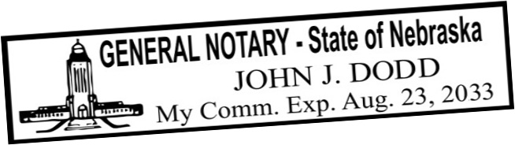
Sample Filled Out Form : Tangible Personal Property List

TANGIBLE PERSONAL PROPERTY LIST

In this writing are gifts of tangible personal property to occur at my death,
but this writing if not found by someone within 90 days of my death is canceled.
I may do many pages of these writings which should all be seen as one document. If there are conflicts among such writings the provisions of the more recent writing will revoke the inconsistent provisions of a prior writing.
If a person getting a gift below does not survive me such gift is void and canceled.

PROPERTY ITEMS NAMES OF RECIPIENTS
1998 Ford Truck | to | Samantha Bell
1.3 carat diamond ring + Irish rings | to | Ann Sue Reed
14 ft power boat + kayak + paddles | to | L. Wheeler
Amish style bench | to | Reba Stewart
glass table, telescope, umbrellas | to | Rebecca Stewart
Irish wood cups, oak platter, red vase | to | Mary and Cindy Lott
painting of sailboat in storm | to | Mary Lott
chainsaw marked with 382937 | to | Mary Lott
chainsaw marked with 89930 | to | Matt Smith
antique lanterns + repair kits | to | Sue Wu maid at Hart Hotel
oak lamp kept on porch | to | Mary Kay Poppler
sewing machines | to | Mary Kay Poppler
rocking chair bought in Oregon | to | Don Winkler boat mechanic
all fishing poles and fishing nets | to | Joe “Fish” Hoss, fishing pal
hats at cabin | to | Ken Baker
 | to
 | to
 | to
 | to

DATE: 8-15-202 SIGNED: David Eric Smith

